**Volleyball**

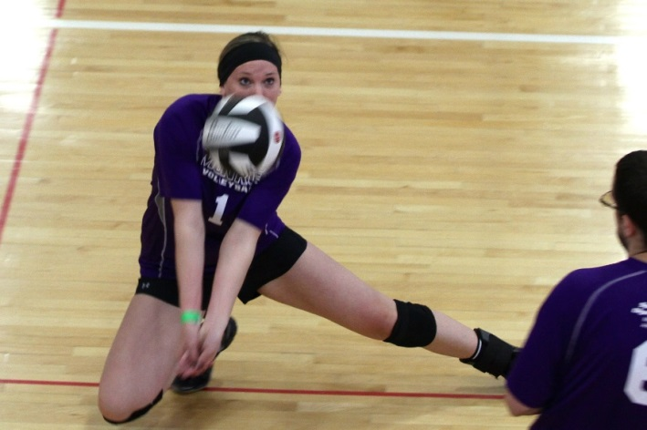

**SOMI-Specific Information**

**Sport season:**

April-June

**Culminating State Events:**

State Summer Games

**Events Offered:**

Individual Skills Competition

Team Competition

Modified Team Competition

Unified Team Competition

**National Governing Body:**

Federation Internationale de Volleyball (FIVB)

7 Place Chauderon 1003 Lausanne,

Switzerland (41.21) 208932-33-34

**Uniform Guidelines**

1. A volleyball uniform is a jersey, shorts, socks and shoes.
2. Numbers should be in the center on the back and front of the jersey. The numbers must contrast with the jersey color.
3. Players' jerseys must be numbered 1 to 99.
4. If undergarments, including but not limited to T-shirts, boxer shorts, tights, leotards, body suits, compression shorts, sports bras, etc., are worn so that they are exposed, they will be considered part of the uniform. In that case, they must be identical for any team member who wears such a uniform. Undergarments should be similar in color to uniform.
5. Kneepads are recommended.
6. Hats, bandanas, du-rags, jewelry, and denim may not be worn during games or practice. Headbands, wristbands, and arm sleeves are acceptable.
7. Headwear for religious or medical reasons are acceptable but must be brought to the attention of the Games Director prior to competition.

**Equipment**

1. Court size is 59’ long by 29’6” wide (18M x 9M).
2. The height of the net for team competition is Male & Coed teams 2.43 meters (7ft, 11 5/8 inches) Female teams 2.24 meters (7' 4-1/8" feet) Unified Men & coed teams 2.43 (7ft, 11 5/8 inches) Unified Women teams 2.24 meters.
3. The service line must be at least 14 feet 9 (28 ½ feet full court size) inches from the net.
4. A regulation size volleyball should be used. The size of the ball should be between 25.6 & 26.4 inches in circumference and weigh no more than 9.1 - 9.8 ounces. It should be as close as possible to the regulation-size volleyball.

**Team Size**

1. A team roster shall consist of at least seven players and no more than 12 players. You must have 6 players to start the set. You can finish with less than 6 but cannot start next match with less than 6.
2. You may register 3 athletes as your team alternates.
3. All team members are required to play a match.
4. Alternates attend the event only when replacing a registered athlete who does not attend. When dropping an athlete prior to a SOMI Culminating Event or at the event site, only registered alternate athletes can be added. Awards are only given to team members listed on rosters and present the day of the event. (Ex. If you have 8 people listed on your original roster you can only bring 8 people to the event, if you drop one athlete they are replaced with one alternate.) It is strongly suggested to list alternate athletes.
5. Each coach must see to it that each athlete has frequent opportunities to participate.

**General Rules**

1. A player may not play the ball twice in succession except when blocking.
2. Any ball hitting the ceiling will be considered playable by the team causing such contact, as long as the ball stays on their side of the court and does not cross the plane of the net.
3. A served ball touching the net shall remain in play, and the receiving team has three plays to return the ball to the opponents.
4. Substitutes
5. A team will be allowed a maximum of 12 substitutions per set.
6. Each player may enter the set three times. Starting the game constitutes as one entry.
7. players reentering the set must assume their original position in the serving order in relation to their other teammates. This rule will be utilized in all levels of competition and divisions.
8. Each team will get two timeouts per set
9. If a team wins the first three sets of the match, the fourth game can be played only if it does not delay the start of the next scheduled match. Coaches and officials need to use their best judgment or play until the time is up. Coaches need to sign scorecards to verify results. This also applies to modified matches where a team wins the first two sets of the match.
10. The first server of each set is the right back player. Thereafter, the right front player rotates to the right back position. The team receiving first service shall rotate upon the first side out.
11. Once a server has scored three consecutive points, his/her team shall rotate to the next server and continue to serve.
12. Serve shall be from the serving area. Stepping on or over the end line or outside the service area as defined by the sidelines upon contacting the ball or jumping to serve shall constitute a violation.
13. The winner of the coin toss may choose to serve, receive or select a specific side of the court. If a deciding third or fifth set is necessary, a coin toss shall again be conducted with the same options.
14. The ball may be hit with any part of the body.
15. Touching any part of the net while playing the ball is a fault. Crossing completely over the centerline with any part of the body except the feet will not constitute a violation unless there is interference. It is a fault to cross completely over the centerline with the foot or feet.
16. For safety reasons, the ‘Pursuit Rule’ will not be in effect. Once a ball has crossed the net between or outside the antennas, it is no longer playable.
17. Any ball landing on the line is considered “in”

**Scoring**

1. All matches, including modified matches, will utilize Rally Scoring. You need not to be serving to score a point.
2. Traditional and Unified division matches will play the best 3 out of 5 sets, with the winner being the team who wins three sets.
3. Modified division matches will play the best 2 out of 3 sets, with the winner being the team who wins two sets.
4. A playoff set is considered a match, and only one game will be played.
5. In Traditional and Unified division matches a set is won by the team that scores 25 or more points with a two-point advantage. In the case of a 24-24 tie, play is continued until a 2-point lead is achieved.
6. In Modified division matches a set is won by the team that scores 21 or more points with a two-point advantage. In the case of a 20-20 tie, play is continued until a 2-point lead is achieved.
7. In the case of a 1-1 (modified) or 2-2 (traditional and Unified) set tie, the deciding set (3rd or 5th) is played as a tiebreaker with rally point scoring procedures to 15 points and no point cap.
8. If a team fails to serve properly, return the ball, or commits any other fault, the opponent wins the rally and scores the point.
9. When the serving team wins a rally, it scores a point and continues to serve. If the receiving team wins the rally, it scores a point and gains the right to serve.
10. Teams change sides when one team has scored eight points.
11. 3 match scores are due to the State Office in order to participate at State Summer Games.

|  |  |  |  |  |  |  |
| --- | --- | --- | --- | --- | --- | --- |
|  | **Set 1** | **Set 2** | **Set 3** | **Set 4** | **Set 5** | **Winner** |
| **Team A** | **25** | 22 | 19 | **25** | **15** | **X** |
| **Team B** | 20 | **25** | **25** | 18 | 13 |  |

**Libero Player**

1. Libero players are players that play defensive positions only. Any team has the option to designate two Libero players on its roster for each match. There are special rules if the Libero player is injured and cannot continue.
2. The Libero jersey number(s) must be placed on the lineup sheet for the first set of the match, in addition to the numbers for the starting six players.
3. The Libero player must wear a uniform of a different and contrasting color and/or design than that of the rest of the team in order to be easily recognized on the court.
4. Libero playing actions:
   1. The Libero is allowed to replace any player in a back-row position, except in Unified Sports competition when an athlete may only replace an athlete and a partner replace a partner.
   2. He/she is restricted to perform as a back-row player and is not allowed to complete an attack hit from anywhere (including playing court and free zone) if at the moment of the contact, the ball is entirely higher than the top of the net.
   3. A player may not complete an attack hit from higher than the top of the net if the ball is coming from an overhead finger pass by a Libero in his/her front zone.
   4. The ball may be freely attacked if the Libero makes the same action from behind the front zone.
5. Libero Replacements:
   1. When the Libero replaces a player in the back zone, it is not counted as a substitution.
   2. Libero replacements are unlimited.
   3. Only the players whom he/she replaced may replace the Libero.
   4. Replacements may take place at the start of the set after the second referee has checked the lineup or while the ball is out of play, before the first referee blows the whistle for service.

**Modified Team Competition**

1. The height of the net for modified team competition will be 7 feet 4-1/8 inches (15 meters x 7 ½ meters).
2. The modified volleyball (32 inches & 8 ounces) will be utilized at Summer Games.
3. One assist on a serve is allowed.
4. The serve line will be moved up to 14’ 9” (4.5 meters).
5. A time limit of 30 minutes may be set for each set.
6. A 3-point serving rule will be used. Once one player has scored 3 points on their serve, there will be an automatic side out.
7. If the ball, after having been tossed or released by the server, is caught or falls to the floor, it is considered a service tossing error. One re-serve is permitted.
8. Antennas will still be placed on the sideline of the smaller court.
9. Two of the three sets to 21 points will determine a match.
10. A team must win each sets by two points.

**Unified Team Competition**

1. Rosters must have a minimum of 7 players and may not exceed 12. The roster shall contain a proportionate number of athletes and partners.
2. During competition, the lineup shall never exceed three athletes and three partners at any time. Failure to adhere to the required ratio results in a forfeit.
3. Each team shall have an adult, non-playing coach responsible for the lineup and conduct of the team during competition.
4. The serving order and positions on the court, at service, shall be an alternation of athletes and partners.
5. Once a server has scored three consecutive points, his/her team shall rotate to the next server and continue to serve.

**Individual Skills Contest**

1. The Individual Skills Contest is designed for lower ability or new athletes who have not yet developed the skills necessary to participate meaningfully in team competition and wheelchair athletes.
2. Athletes may not be assisted by coaches.
3. Modifications will be made for athletes who have visual or hearing impairments.
4. The athlete's final score is determined by adding together the scores achieved in each of the events.

|  |
| --- |
| **Volleyball Individual Skills Contest** |
| Overhead Passing |
| Serving |
| Passing (Forearm) |

**Event #1 - Overhead Passing**

1. **Equipment**: Use a regulation-size court that is 18 meters (59 feet) long and 9 meters (29 feet, 6 inches) wide, four volleyballs (modified ball permissible), net height at 2.24 meters (7 feet, 4 1/8 inches) for women and 2.43 meters (7 feet, 11 5/8 inches) for men, standards, antennae and ball box.
2. **Description**: Player is given 10 attempts from the center front position that is 2 meters (6 feet, 6 3/4 inches) from the net and 4.5 meters (14 feet, 9 inches) from the sideline. The player receives 10, two-handed, underhand-tossed balls from the tosser who is positioned in his/her backcourt, 4 meters (13 feet, 1 1/2 inches) from the baseline and 3 meters (9 feet, 10 inches) from the sideline in the left back position. The player sets the tossed ball toward a target (a person who has his/her hands above the head and who is standing 2 meters from the net and 2 meters from the sideline in the left front position). Tosses that are not high enough for the athlete to set are repeated. The goal is for the peak of the arc of each set ball to be above net height.
3. **Scoring**: The peak of the arc of each set ball toward the target is measured. The athlete will receive one point for volleying/setting the ball 1 meter (3 feet, 3 1/3 inches) above his/her head height and three points for volleying/setting the ball above net height. The following result in zero points: illegal contact, balls which go lower than head high and balls which go over the net or outside the court. The athlete’s final score is determined by adding together the points awarded for each of the 10 attempts. (It is suggested that the official stand on a chair to evaluate the height of each set).

**Event #2—Serving**

1. **Equipment**: Use a regulation-size court that is 18 meters (59 feet) long and 9 meters (29 feet, 6inches) wide, five volleyballs (modified ball permissible), net, standards, antennae, measuring tape, floor tape or chalk and ball box.
2. **Description**: The athlete stands 1.5 meters inside the end line and serves 10 volleyballs, one at a time, into the opponent’s court.
3. 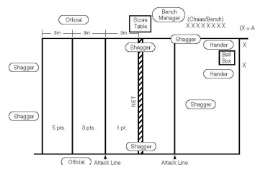**Scoring**: The court is divided into three equal areas of 3 meters in width. Each of these areas is assigned a different point value. The athlete’s score is the cumulative point total of the 10 serves. A ball which lands on the line is assigned to the area with the highest point value.

**Event #3 - Passing (Forearm)**

1. **Equipment:** Use a regulation-size volleyball court that is 18 meters (59 feet) long and 9 meters (29 feet, 6 inches) wide, five volleyballs (modified ball permissible), net, standards, measuring tape, marking tape and ball box.
2. **Description:** The athlete stands at the right back position, 3 meters [9’10‖] from the right sideline and 1 meter [3’3 1/3‖] from the baseline. A ball is thrown, using a two hand, overhead toss by a coach/official who is standing on the same side of the net in the center front position, 2 meters (6 feet, 6 3/4 inches) from the net. The athlete receives the toss and passes the ball toward a target (a person who has his/her hands above the head and who is standing on the same side, 2 meters away from the net, and 4 meters [13 feet, 1 1/2 inches] from the sideline away from the tosser). Target areas of varying point values are marked on the front court. The event is repeated with the athlete at the left back position, 3 meters from the left sideline and 1 meter from the baseline.
3. **Scoring:** The athlete must pass the ball so that the peak of the arc is at least net height in order to receive maximum points. A ball which lands on the line is assigned to the area with the higher point value. A ball which is passed below net height will receive only one point, regardless of where it lands. The athlete’s final score is determined by adding together the points scored from his/her five attempts at both the right back and the left back positions. It is suggested that the official stand on a chair to evaluate the height of each pass.