**Speed Skating**

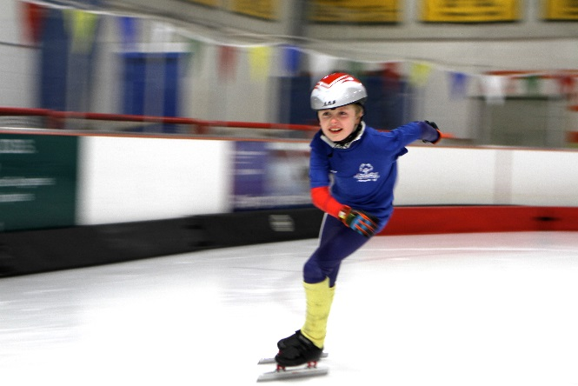

**SOMI-Specific Information**

**Sport season:**

December-February

**Culminating State Event:**

State Winter Games

**Events Offered:**

100-meter

300-meter

500-meter

800-meter

3000-meter Unified Relay

**National Governing Body:**

International Skating Union (ISU)

Promenade 73

7270 Davos-Platz, Switzerland

(41.83) 3757

**Uniform Guidelines & Equipment**

1. All speed skaters will wear long-sleeved uniforms, knee pads, shin guards, and cut resistant throat protectors, cut resistant and no protrusions (which might get caught on a blade) gloves/mittens of a protective nature, and an approved safety helmet with a hard shell and chin strap.
2. All helmets must be an ISU approved helmet and be free of protrusions. Helmet air vents shall not be large enough for the blade of a skate to pass through. Helmet selection should be made with the help of a knowledgeable speed skating coach or skate shop employee.
3. Elbow pads and Kevlar throat/neck protector are optional.
4. Skates: Speed skaters should wear speed skates. In the event speed skates are not available to the athlete, hockey skates may be used. Figure skates and Klap style speed skate blades are not permitted.
5. All competitors must wear competition numbers for both time trial and final races.
6. Competition equipment, such as skates, must pass all appropriate safety guidelines. All clothing should be made of material conducive to freedom of movement. Athletes are encouraged to bring warm clothing for after the competition.
7. Jewelry and denim may not be worn during competition or practice. Headwear for religious or medical reasons are acceptable but must be brought to the attention of the Games Director prior to competition.

**Rink Layout**

1. All events will be conducted in a short track format.
2. The track shall be set on an ice rink with a minimum length of 56.38 m and a minimum width of 25.90 m.
3. If the facility used for competition has an ISU 111 meter track surveyed on the ice surface, this track may be used for competition purposes. Proper notation must be made on competition reports on the size of track use. If a 111-meter track is used the distance and laps are:

1 lap = 111 m

3 laps = 333 m

4.5 laps = 500 m

7 laps = 777 m

1. The center of the track should be set at the middle of the rink.
2. The start/finish line shall be clearly defined using track markers on the sides of the track.
3. Nothing shall be placed in or above the competitors' paths, or on or above the ice (except markers).
4. Safety mats must be present during all training and competition periods.
5. Rink barriers shall be covered by mats from the curve apex block to the centerline of the rink. The mats shall be of double thickness along the rink barrier on the far side of the curve. Mats shall be attached to the rink barrier with their weight on the ice. Mats should be made in such a manner and of such materials that they will minimize debris which might accumulate on the ice as a result of use of the mats. Mat height must be adequate to cover the height of the wall of the ice rink. Outdoor non-barrier ice surfaces do not need mats but must have adequate fall lines to protect the skater from possible collision with any stationary object present; i.e. tree.
6. Start/Finish lines for races on a 111.12-meter track are indicated below:



**Rules**

1. Each athlete participating at Winter Games may only compete in one sport.
2. Each athlete may participate in two events within the chosen sport category. Special attention should be directed to recommend events for the athlete’s ability level.
3. Athletes may enter the 3000M Unified Relay as a 3rd event.
4. Speed Skaters must go to the middle of the rink to stop. A skater who uses the wall to maintain balance or to assist in propelling oneself forward is considered assistance and will be disqualified.
5. Start Equipment
   1. A start pistol or whistle shall be used to begin each race. False starts will require a restart.
   2. For hearing impaired skaters, dropping a hand or flag shall accompany the sound of the gun.
6. Track Markers
   1. Moveable markers of rubber or other suitable material shall be used to mark the track. The number of markers should be sufficient to define the track clearly.
   2. Seven markers shall be used to define each curve (turn) with the distance between every other marker being the radius of the curve.
   3. No track markers shall be of such size and width, or be fixed to the ice, so that they will not move freely if they are struck by a skater.
   4. The height of the markers should not be over 5.08 cm in height as to be struck by a skater. Cones are too tall and are not acceptable for marking the track.
7. Race Start
   1. All skaters shall start a race with both skates behind the start line. A speed skater shall finish the race when the blade of one of his/her skates first crosses the finish line after completing the appropriate number of laps in the race.
   2. The starter shall give each skater a chance to do his/her best by:
      1. Giving the skaters ample time to settle down and assume a balanced position after taking their marks
      2. Starting the sequence over if any skater is off-balance
      3. Not holding the skaters too long after the set signal,
      4. Always using the starting commands and signals
   3. If a skater is interfered with and falls before the last apex block of the starting line, the skaters may be called back to make a new start. The decision whether the interference is an offence according to the Racing Rules is decision of the Referee.
   4. The starter shall position himself/herself in front of the start line in such a way that he/she is clearly visible and distinguishable as the starter to all skaters starting the race.
   5. Races shall not start until the gun is fired or the whistle is blown. Skaters making two false starts shall be disqualified.
   6. Maximum effort rule will not be applied to events that have a semi-final and a final.
   7. There shall be exactly two competitors on the track competing at the same time unless there is an odd number of competitors in a particular division, then three competitors shall compete at the same time during one heat within that division.
   8. When there is an even number of competitors within a division, the order of start shall be determined by a random draw of the competitor names. The first and second names drawn will be the first pair of skaters to come in that division, the third and fourth names to be drawn will be the second pair, and so on until all names are drawn.
   9. The skaters whose names were drawn on even numbered draws shall be assigned to the starting position toward the end of the starting line closest to the rink barrier, on the outside of the track.
   10. The skaters whose names were drawn on odd-numbered draws shall be assigned the starting position toward the end of the line furthest from the rink barrier, on the inside of the track.
   11. When a skater has completed his laps and crosses the finish line, they need to return to the center of the rink.

**Start Commands:**

1. "Go to the start" (skaters step to start line and place skaters behind the start line),
2. "Ready" (skaters get down into start position),
3. Signal the start of the race with the firing of a start pistol or blowing a whistle.

**Disqualifications**

1. When overtaking, the responsibility for any obstruction or collision shall be upon the skater overtaking, provided that the skater being overtaken does not act improperly. A skater on the outside of the track shall be deemed to be the skater overtaking if the skaters are side-by-side entering the first curve.
2. A skater shall not deliberately impede or push another skater with any part of his/her body, thereby gaining an advantage. Any skater who willfully impedes, improperly crosses the course or, in any way interferes with another skater, or conspires with others to cause a race to result otherwise than on its merit, shall be disqualified.
3. Any skater, who unnecessarily slows down, thereby causing another skater to slow or collide, shall be disqualified.
4. A skater who permits himself/herself to receive physical assistance during a race that is not a relay shall be disqualified.
5. A skater who uses the wall to maintain balance or to assist in propelling oneself forward is considered assistance and shall be disqualified.
6. A skater shall be disqualified for intentionally moving the corner track markers or failing to skate at all times outside the corner track markers.
7. The Referee may disqualify a skater from a race if the skater deliberately kicks out a skate or throws his/her body across the finish line thereby endangering another skater at the finish line.
8. A disqualification must be announced at the end of each heat to the skater, team leader, or coach and over the public address system for the benefit of the spectators.

**Unified Sports Relay Races**

1. Each team shall consist of two Special Olympics Athletes and two Unified Sports® Partners.
2. Selection of Special Olympics Athletes and Unified Sports® Partners of similar age and ability is required for Unified Sports® training and competition in Speed Skating. Significant risk of injury could result from teams where athletes and partners are poorly matched.
3. No more than two relay teams shall be allowed on the ice at any time.
4. Each team member must skate a minimum of three laps. The last two laps must be skated by a single skater that will be an Athlete member of the team.
5. Each team shall draw for which side of the track (near/far in relation to the finish line) on which they will be allowed to relay.
6. Each team shall be clearly identified by wearing the same uniform or by wearing the same color pinnie vest or helmet bib.
7. The relay zone will be between the blue hockey zone lines (middle portion of the straightaway).
8. The relay may be by either push start or tag of hand.
9. No other personnel, other than the referees, will be on the ice to allow the infield of the track to be used for marshaling and pacing for relay exchanges.