Gymnastics, Artistic
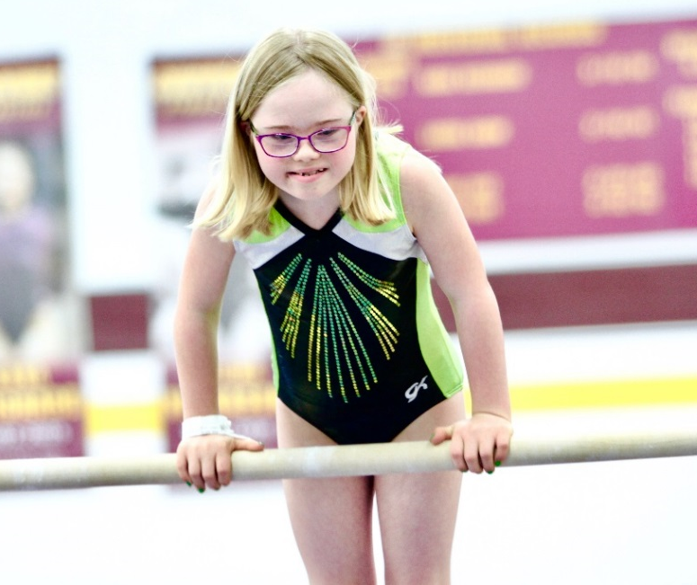

SOMI-Specific Information

Sport season:
March-June

Culminating State Event:
State Summer Games

Events Offered:
Women’s Events (Levels I, II, III and IV)
- Vaulting
- Uneven Bars
- Balance Beam
- Floor Exercise
- All Around (total of all four event scores)

Men’s Events (Levels I, II, III, and IV)
- Floor Exercise
- Pommel Horse
- Vault
- Parallel Bars
- Horizontal Bar
- All Around (total of all five event scores)

Mixed Gender Events (Levels A, B & C only)
- Vaulting
- Single Bar
- Wide Beam
- Floor Exercise
- Pommel Horse
- Horizontal Bar
- All Around (total of all four event scores)

National Governing Body:
Federation Internationale de Gymnastique (FIG)
Juraweg 12 3250 Lyss
Switzerland 290-2471

Uniform Guidelines & Equipment
- For male gymnasts, the preferred uniform is a tank top (leotard) and long manufactured gymnastics pants or shorts. A T-shirt that is tucked in may replace the tank top.
- For female gymnasts, the preferred uniform is a long-sleeved manufactured gymnastics leotard with bare legs. Flesh-colored tights with bare feet are permitted, but not recommended. Sleeveless leotards may be worn if temperature or body type warrants it.
- Gymnasts may compete in bare feet or gymnastics slippers.
- Bandages may be worn as long as they are securely fastened.
- Hip padding is not permitted.
- The only jewelry allowed is stud earrings.
- Gymnastic leotards can be purchased from www.gkelite.com
- Starting numbers may be required for technical and organizational purposes.
- Denim may not be worn during competition or practice

General Rules
- All athletes can register for 1 to 4 events.
- Athletes who register for Artistic Gymnastics may not enter Rhythmic events.
- An athlete who enters a Level A event (developmental) may not enter other gymnastics events in levels I thru IV.
- Athletes may enter all 4 events and compete for an All-Around award, (which will be a special medal) or be a specialist, competing in one, two, or three events (or four events for males). All-Around athletes must compete in the same level for all events; specialists may be one level apart for their events. You must register your athletes in GMS for the all-around event to be eligible for the special medal. Only All-Around athletes will be eligible to advance to USA or World Games competitions.
- A score and levels must be entered at registration.
- Gymnasts will now rotate by assigned group or area to specific principal (event).
- There are six levels of competition:
- Level A – Compulsory routines for gymnasts who have ambulatory problems, etc., but are too advanced for the MATP (Mixed Gender)
- Level I - Beginner Compulsory
- Level II - Intermediate Compulsory
- Level III - Advanced Compulsory
- Level IV – Advanced Optional
- Level B- Compulsory routines for gymnasts who are unable to perform level I routines
- Level IV gymnasts perform an optional routine.
- The text for all the routines is usually written for right dominant athletes. Left dominant athletes can reverse the whole routine to accommodate their dominant side. Once the routine is started on the dominant side, all aspects of the routine are executed on that same side. It is not recommended that the athlete change from the dominant side to the non-dominant side during any routine. Doing so will add extra steps/movements to the routine which will result in the athlete being deducted for extra steps/movements.
- If an athlete has Down syndrome, he/she will no longer be required to automatically undergo an x-ray as a requirement for participation. If an athlete was x-rayed at the time of registration, and was found to have an Atlantoaxial instability condition, he/she may follow the new rule and be examined for symptoms of adverse neurological effects. The athlete would need to be cleared by a licensed medical professional in order participate. If the athlete does not have these symptoms, he/she may be cleared for participation by a licensed medical professional.
- Age group divisions will be as follows: 8-11, 12-15, 16-21, 22-29, and 30+. Schedules are sometimes presented as junior (8-15) and senior (16+).
  - Age groups may be combined if there are not a sufficient number of athletes to have a competitive division.
Event-Specific Rules and Modifications
- Athletes with hearing or visual impairments are allowed cues and signals from the coach. Coaches must notify the meet director and judges of the athlete’s impairment before the event begins.
- Modifications for athletes using canes or walkers: In the floor exercise, coaches may walk onto the floor and remove (and replace) walkers and other aids as needed without any deduction.

Disqualifications
A competitor may be disqualified if he/she:
- Is wearing improper attire.
- Undisciplined or unsportsmanlike behavior.
- Improper equipment and use of aids.
- Has assistance from a coach during a competition.

Routines
All artistic routines for 2020 have been updated. To view videos of the NEW artistic routines please visit:
http://resources.specialolympics.org/topics/sports/Artistic_compulsories.aspx

