**Flag Football**

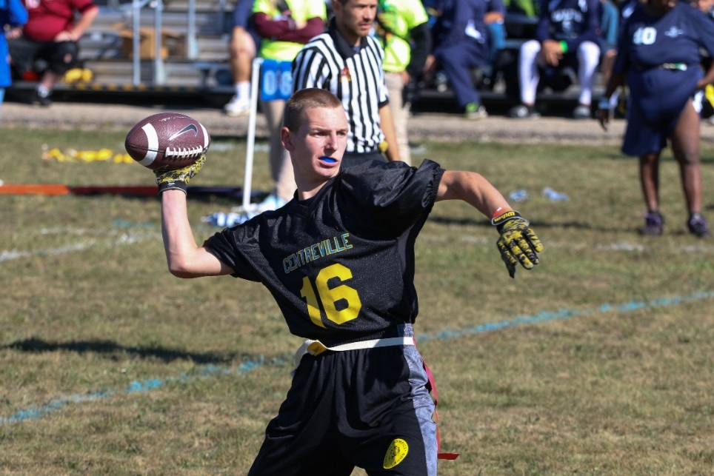

**SOMI-Specific Information**

**Sport season:**

June-September

**Culminating State Events:**

State Fall Games

**Events Offered:**

Individual Skills Competitions

Traditional Team

Unified Team

**Uniform Guidelines**

1. Uniforms consist of a jersey, shorts, and sport shoes. All team members must have identical uniforms in color and design. The Special Olympics Michigan logo must be on the jersey. The area will be FINED the cost of putting the logos on the uniforms for each team sport without logoed uniforms. Area Directors will be notified.
2. Athletes may wear rubber-cleated or flat soled athletic shoes. Metal cleats, spikes, hiking boots or other equipment deemed dangerous by officials will not be allowed.
3. Team jerseys must be the same solid color front and back and must be tucked in at the waist. Jerseys may not hang over flag belts. Numbers must appear on the front and the back of each athlete's jersey. A team roster shall not have both numbers 0 and 00. All players must wear athletic shorts without pockets.
4. Hats, bandanas, du-rags, jewelry, and denim may not be worn during games or practice. Headbands, wristbands, and arm sleeves are acceptable. Headwear for religious or medical reasons are acceptable but must be brought to the attention of the Games Director prior to competition. Jewelry is not allowed.
5. All players must have a mouthpiece to be used during competition at all times.

**Equipment**

1. A regular or intermediate (youth) sized football will be used in all divisions. Each athlete will wear a one piece, three-flag belt during competition. The flags should be located one on each hip and one on the backside.
2. A protective mouthpiece must also be worn at all times during competition.
3. A special marker will be placed seven yards from the line of scrimmage to mark the spot the defensive player rushing the quarterback must start behind.

**Playing Field**

1. The playing field is 60 yards long (including the end zones) and 25 yards wide. If insufficient space is available, a slightly smaller space can be used. A space of at least 5 yards around the field must be free and clear of obstructions. The field can be marked with chalk, paint, and/or traffic cones.
2. No-Run Zones are in place to prevent teams from conducting power run plays. While in the No-Run Zones (a 5-yard imaginary zone before midfield and before the end zone), teams cannot run the ball in any fashion. All plays must be pass plays, even with a handoff.
3. Stepping on a boundary line is considered out of bounds.
4. Each offensive team approaches only TWO (2) No-Run Zones in each drive (a 5-yard zone before midfield to gain the first down and before the end zone, 5 yards from the goal line to score a TD).



**Team Size**

1. A team roster shall consist of at least a minimum of 6 players and no more than 10 players. A team may not start a game with less than five players. In the event of an injury teams may finish a game with 4 players. The game may continue with fewer players as long as the team has a chance to win (at the discretion of game officials). However, the next game may not start with less than 5 players.
2. You may register 5 athletes as your team alternates.
3. Alternates attend the event only when replacing a registered athlete who does not attend. When dropping an athlete prior to a SOMI Culminating Event or at the event site, only registered alternate athletes can be added. Alternates do not attend state events unless activated in the sport.
4. Awards are only given to team members listed on rosters and present the day of the event. (Ex. If you have 8 people listed on your original roster you can only bring 8 people to the event, if you drop one athlete, they are replaced with one alternate.) It is strongly suggested to list alternate athletes. Unified Partner athletes will follow the same procedures as athlete alternates.
5. Each coach must see to it that each athlete has frequent opportunities to participate.
6. All coaches are required to turn in 3 scores prior to the state event, in which their roster must be the same for all 3 scores.
7. For Unified Sports the roster shall contain a proportionate number of traditional athletes and unified partners. During competition, the line-up shall never exceed three traditional athletes and two unified partners at any time. If a team is unable to play by these numbers, then a forfeit will be issued.

**Flag Football Rules**

1. Special Olympics Flag Football is non-contact. In all aspects of Special Olympics Flag Football, rulings shall be made with player safety as the primary consideration.
2. No team shall repeatedly commit penalties which halve the distance to the goal line.
3. Neither team shall commit any act which, in the opinion of the referee, tends to make a travesty of the game. This includes intentionally committing penalties to gain an advantage. The referee will enforce any penalty he/she considers equitable, including the award of a score for an unfair act.
4. A coin toss determines first possession. Each team will provide two (2) captains, the officials and team captains will meet three (3) minutes prior to the start of the contest to conduct the coin toss. The visiting team captain will be given the choice of heads or tails prior to the toss. The winner of the coin toss will choose offense, defense, or end of field to defend. The team winning the coin toss may defer its choice to the second half.
5. Possessions
   1. All possessions, except following an interception, start at the offensive team’s 5- yard line.
   2. The offense has four (4) plays to cross mid-field, once the offense crosses mid-field, they have four (4) additional plays to score a touchdown. If the offensive team fails to cross mid-field or score a touchdown in a prescribed number of plays, possession of the ball changes and the opposite team starts at their 5-yard line.
   3. The ball carrier may not dive, hurdle, stiff arm, or use either arm to shield a defender from grasping his/her flag.
   4. When determining forward progress, mark the forward point of the ball, not the player, when the ball becomes dead by rule (ball carrier’s flag belt is pulled or hand/knee touches ground, whistle sounds, etc.).
6. Timing
   1. The game shall consist of two (2) 20-minute halves with a running game clock.
   2. Officials can stop the clock at their discretion (injuries, delays).
   3. The clock will stop on all time-outs; each team receives one (1) 60-second time-out per half, an unused time-out in the first half does not carry over to the second half.
   4. There shall be a 5-minute break at halftime.
   5. The ball must be put in play within 30 seconds of the previous play ending, any action or lack of action by either team that tends to prevent this is considered a delay of game.
7. Delay of Game -Includes:
   1. Interrupting the 30-second count for any reason except for a granted time-out,
   2. Consuming more than 30-seconds to snap the ball after it is ready for play,
   3. Failing to remove an injured player for whose benefit an excess time-out has been granted,
   4. Deliberately advancing the ball after it has been declared dead.
8. Overtime- If the score is tied at the end of regulation play:
   1. A coin toss is held to determine the first possession.
   2. If multiple overtimes occur teams will alternate first possessions i.e. team that started with the ball in the first overtime will possess the ball second in the second overtime.
   3. Each team receives two (2) plays from midfield and the team gaining the most points or gaining a yardage advantage is awarded one (1) extra point and wins the game.
   4. Exceptions to this rule: 1) If there is an interception; the team that intercepts the pass automatically wins the game. 2) If the team with the first attempt in overtime scores on the first play, the opposing team must score on its first play also. There are no extra point attempts in overtime.
   5. If both teams score a touchdown, or gain the same yardage, the procedure is repeated until one (1) team wins.
   6. No time-outs are allowed in overtime play.
   7. All regulation rules and penalties are in effect
9. Scoring -
   1. **Touchdown**: six (6) points.
   2. **Extra Point:** one (1) point from the 6-yard line, two (2) points from the 12-yard line (or any distance outside 6 yards due to a penalty). Penalty enforcement will change the spot of the attempt, not the point value of the extra point attempt.
   3. **Safety**: two (2) points.
10. Positions/Snap -The ball must be snapped between the Center’s legs to start each play. No minimum number of players is required to line-up on the line of scrimmage.
11. Dead Balls/Fumbles -There are no fumbles, play is ruled dead when:
    1. The ball carrier’s flag is pulled;
    2. The ball carrier loses his/her flag;
    3. The ball carrier steps out of bounds;
    4. The ball carrier’s knee or hand touches the ground;
    5. A touchdown, extra point, or safety is scored;
    6. When during a try-for-point the defense obtains possession of the ball;
    7. When a forward pass strikes the ground or is caught simultaneously by opposing players (the offense retains possession);
    8. A pass is intercepted (no returns);
    9. A receiver catches a ball without his/her flags attached;
    10. A snapped ball touches the ground;
    11. If fumbled forward, the ball is spotted where the ball carrier’s feet were at the time of the fumble. If ball falls backwards, it is marked where it hits the ground;
    12. When there is an inadvertent whistle.
12. Inadvertent Whistle -In case of an inadvertent whistle, the team in possession of the ball may choose to accept the result of the play at the point where the play was blown dead or choose to re-play the down.
13. Substitutions
    1. Any player on the roster may enter upon the completion of a play (Dead Ball).
    2. A replaced player must leave the field immediately.
    3. Each substitute must play at least one (1) down prior to being replaced.
14. False Start - No member of the offensive team may simulate the start of the play before the ball is snapped.
15. Running
    1. The Quarterback (first player gaining possession of the snap) cannot advance the ball across the line of scrimmage at any point during a down, even if a legal handoff has occurred (illegal procedure).
    2. Ball carriers MUST make an effort to avoid defenders with an established position.
    3. Only direct hand-offs behind the line of scrimmage are legal.
    4. Laterals or pitches (known as backward passes) are not allowed.
    5. In Unified Sports® divisions, a partner may handoff to a partner behind the line of scrimmage.
    6. The player who takes a hand-off can pass the ball, as long as he/she does not pass the line of scrimmage.
    7. “No Running Zones” are located 5-yards before the mid-field line and goal line. Any ball snapped from on, or in, these zones must be passed.
       1. The purpose of “No Running Zones” is to avoid short yardage power running situations.
    8. The ball carrier may not spin, dive, hurdle, stiff arm, or use either arm to shield a defender from grasping his/her flag.
    9. The ball is marked at the spot where the position of the ball is when the player is declared down (carrier’s flag belt is pulled or hand/knee touches ground).
16. Handling the Ball by the offense - Handling the ball is transferring player possession from one teammate to another without throwing or kicking it. Only direct handoffs behind the line of scrimmage are permitted. Handoffs may be in front, behind, or to the side of the quarterback/offensive player, but must be behind the line of scrimmage. The offense may use multiple handoffs behind the line of scrimmage.
    1. “Center Sneak” – The ball must completely leave the center’s hands on the snap and he/she must step backwards off the line of scrimmage in order to receive the direct handoff from the quarterback/offensive player before advancing the ball.
17. Hurdling - Jumping over, or attempting to jump over, a player, by the ball carrier, to prevent from being downed or to gain additional yardage is illegal. Note: Jumping over a player who is on the ground to avoid injury, by official’s judgment, is legal.
18. Shielding (Flag Guarding) - Runners shall not shield (flag guard) by using their hands, arms, or the ball to deny the opportunity for an opponent to pull or remove their flag belt. This includes:
    1. Swinging the hand or arm over the flag belt;
    2. Stiff arms;
    3. Placing the ball in a possession over the flag belt;
    4. Lowering the shoulders or arm over the flag belt;
    5. Hurdling.
    6. Contact must occur for a flag guarding penalty to be called.
19. Diving - A defensive or offensive player may dive to catch a pass. Diving is illegal when used to down a player or advance a ball. A player cannot dive in an attempt to gain extra yardage. The team will be penalized accordingly.
20. Passing and Receiving
    1. All passes must be forward and received beyond the line of scrimmage.
    2. Shovel passes are allowed, but must be received beyond the line of scrimmage.
    3. All players are eligible to receive a forward pass, including the Quarterback, if he/she has first legally handed-off.
    4. Exception: In Unified Sports® divisions, if a partner throws a pass, only athletes are eligible receivers.
    5. Only one (1) player is allowed in motion at the snap and he/she may not be moving toward the line of scrimmage at the snap.
    6. A player must have at least one (1) foot in bounds when making a catch.
    7. Interceptions change possession of the ball at the point of the interception, no returns are allowed.
    8. Exception: A ball intercepted in the end zone is spotted at the 5-yard line.
21. Eligible Receiver - All offensive players are eligible to receive a pass, except in Unified Sports® divisions where partners are ineligible when partners are throwing the pass; Unified Sports® teams are expected to comply with this rule without intervention by officials. Failure to “self-patrol” will be considered unsportsmanlike and will be penalized accordingly. If a player steps out of bounds, he/she may not be the first player to touch the ball.
22. Rushing the Quarterback (QB) - All players who rush the Quarterback must be a minimum of 7-yards from the line of scrimmage when the ball is snapped. A special marker, placed by the official, will designate the spot 7-yards from the line of scrimmage when the ball is snapped. Players not rushing the quarterback may defend the line of scrimmage. Once the Quarterback hands off the ball, the 7-yard zone no longer exists, and all defenders are eligible to rush.
23. Screen Blocking - Legally obstructing an opponent without contacting him/her with any part of the screen blocker’s body. The blocker may not impede the progress of a defensive player with contact. The screen blocker shall have his/her arms fully extended to the ground (below the waist) either at his/her side, in front, or behind his/her back. Arms may also be crossed over the chest with hands near the shoulders. Any use of arms, elbows, legs, or shoulders to initiate contact during the screen block is illegal. A player must be on his/her feet before, during, and after screen blocking. Screen blocking is the only form of legal blocking that can be used by any player at any time. If any of the provisions listed are violated, and contact results, the screener has committed an illegal block.
24. Backfield Blocking:
    1. The screen blocker must give an opponent at least one (1) step.
    2. The screen blocker must not initiate contact with opponent.
    3. The screen blocker may not take a position so close to a moving opponent that this opponent cannot avoid contact by stopping or changing directions.
    4. After assuming a legal screen blocking position, a player may move to maintain it, unless they move into an opponent and create contact.
25. Downfield Blocking
    1. A basketball style (non-moving screen block) screen is the only acceptable form of downfield blocking
    2. The blocker may not run between a defender and ball carrier in a manner that impedes a defender’s progress to the flag.
26. Flag Pulling - A legal flag pull takes place when the ball carrier is in full possession of the ball. It is illegal to pull or strip the ball from the carrier’s possession at any time. If a player’s flag belt inadvertently falls off during the play, the player is down immediately upon possession of the ball and the play ends. A defensive player may not intentionally pull the flags off a player who is not in possession of the ball. A flag is considered pulled when the clip is no longer attached to the opposite side of the belt. Defenders may not dive in an attempt to pull flags (illegal procedure). The official may pull flag belts after a score, to show if was legally secured.
27. Line of Scrimmage - The line of scrimmage for each team is a vertical plane through the point of the ball nearest the team’s goal line. Each player on a team must be on its side of the line of scrimmage when the ball is snapped.
28. Motion - Only one player of the offensive team may be in motion at the snap; this player must be behind the line of scrimmage and not moving toward the line of scrimmage at the time the ball is snapped. If the player comes to a stop, he/she must be set for one (1) second.
29. Shift - A shift is the action of one (1) or more offensive players who after taking set positions move to a new position prior to the snap. A player who shifts must reset for one (1) second prior to the snap.
30. Snap - A snap is the legal act of passing the ball through the Center’s legs from the ground to the Quarterback to start a play. The ball may be snapped between the center’s legs or to the side. The snapper’s legs must be behind the line of scrimmage. The snapper shall transfer the ball from its position on the ground in a continuous motion to the quarterback to legally start a lay. The snapper is the only player required on the line of scrimmage at the time of the snap.

**Unified Flag Football Rules**

1. The roster shall contain an equal number of traditional athletes and unified partners, equal means at least 3 traditional athletes and 3 unified partners.
2. Roster should consist of a minimum of 7 players and a maximum of 10 players. During competition, the line-up shall never exceed three traditional athletes and two unified partners at any time. If a team is unable to play by these numbers, then a forfeit will be issued. A team may not start a game with less than five players. In the event of an injury teams may finish a game with 4 players. The game may continue with fewer players as long as the team has a chance to win (at the discretion of game officials). A minimum of 1 athlete and 1 unified partner is required on the field. However, the next game may not start with less than 5 players.
3. Teams may register up to 5 alternates for their team – 3 athletes and 2 unified partners.
4. Each team shall have an adult non-playing Head Coach responsible for the line-up and conduct of the team during competition.
5. Unified Partners are athletes and should not be involved in coaching. Coaches should monitor their players to ensure that all players are contributing to the team's success and that an individual player is not dominating the game. Assistant Coaches may be on the team roster and play.
6. If a unified partner is not allowing the entire team to be a part of the game, it is the coach's responsibility to remove that player.
7. If an opposing coach feels that a partner is dominating the game, he or she should notify the Games Rules Committee while the incident is occurring. The rules committee will observe the game immediately. If they agree that a partner is dominating the game, they will speak to the coach and request that the coach discuss the philosophy of the Unified Sports® program with the athlete. If the player continues to dominate after this discussion with the coach, the Games Rules Committee will remove the player from the game. If the coach puts the player back in the game, the team will forfeit.
8. Unified Partners as quarterbacks may not pass to another Unified Partner.
9. Unified Partners may hand-off to another Unified Partner.
10. The unified partner must complete the Application for Participation for unified partner.

**Penalties**

1. A coach or designated captain will have the opportunity to decline or accept the penalty based on the result of the play.
   1. Officials may not ask for a decision when the penalty enforcement is obvious
   2. The yardage may be declined when accepting a penalty.
2. All penalties are assessed from the line of scrimmage and no penalty may take the ball more than half the distance to the offender’s goal line.
   1. Penalties occurring after the dead ball will be assessed from the new line of scrimmage.
3. Unsportsmanlike conduct
   1. The officials will disqualify any player who participates in rough or unsportsmanlike play
   2. During player possession, it is illegal for a defensive player to strip of pull the ball from the ball carrier at any time
   3. No warning is required
   4. Ball carriers must make an effort to avoid defenders with an established position
   5. Defenders are not allowed to run through the ball carrier when pulling flags
   6. Tackling will result in a disqualification.

Penalties Include:

1. Offense - 10-yards from the line of scrimmage and loss of down:
   1. Illegal Motion (more than one (1) player moving at snap, moving forward at snap);
   2. Offside (in neutral zone at snap, false start);
   3. Illegal forward/backward pass (pass not completed beyond line of scrimmage; illegal backward pass; Partner to Partner; QB pass beyond line of scrimmage);
   4. Illegal Procedure (quarterback run);
   5. Pass Interference (picking or pushing defender);
   6. Illegal Contact (holding, blocking, bumping, stiff arming);
   7. Flag Guarding (driving, spinning, warding off, hurdling); and
   8. Delay of Game (failing to snap within 30 second of ready).
2. Defense - 10-yards from the line of scrimmage and automatic first down:
   1. Offside (in or beyond neutral zone at snap);
   2. Pass Interference;
   3. Illegal Contact (holding, blocking, bumping, stripping);
   4. Illegal Flag Pull (before receiver has ball); and
   5. Illegal Rushing (rushing Quarterback inside 7-yard line).

**Individual Skills Contest**

The Individual Skills Contest is designed for lower ability or new athletes who have not yet developed the skills necessary to participate meaningfully in team competition and wheelchair athletes. Athletes may not be assisted by coaches. Modifications will be made for athletes who have visual or hearing impairments.

The athlete's final score is determined by adding together the scores achieved in each of the events. For diagrams and rules for each event please visit somi.org/sports/sports.html -> Flag Football.

|  |
| --- |
| **Events** |
| Run & Catch |
| Throw for Accuracy |
| Throw for Distance |
| Hand Off |
| Flag Pulling |

**Catching: “Run & Catch”**

1. Purpose: To measure athlete’s ability to catch a football.
2. Equipment: 5 footballs, measuring tape, field paint, cones, or numbered mats to mark catching spots and start/finish lines.
3. Description: A starting line, finish line, quarterback box, and 5 catching spots should be marked/ placed on the field. The catching spots should be marked 1-5 (left to right). (See Figure M)
   * 1. The quarterback box should be placed in between the starting and finish line.
     2. The quarterback box will be 4 yards X 4 yards.
     3. Catching spots are 1 yard X 1 yard.
     4. Catching Boxes 1 & 5 will be 5 yards from the quarterback box.
     5. Catching Boxes 2 & 4 will be 12 yards from the quarterback box.
     6. Catching Box 3 will be 20 yards from the quarterback box.
     7. The starting line should be placed on the left side of the quarterback and the finish line should be placed on the right side of the quarterback. Athletes will start to the left of the quarterback and finish on the right side of the quarterback.
     8. Each athlete will begin at the starting line. Once the official quarterback gives the signal, the athlete must run to each catching box (in numerical order), stopping to catch a pass at each spot. Once the ball is completely caught, the athlete drops the ball and goes to the next catching box. Once the last ball is caught, the athlete will sprint through the finish line. If a throw from the QB is deemed inaccurate, athletes will receive an additional throw from the same spot.
4. Scoring: Athletes will receive points for completing catches.
5. 2 pts: for a complete catch (clearly caught with both hands)
6. 0 pts: if athlete is unable to catch or touch a well-thrown pass.
7. Athletes can gain a maximum of 10 points in this drill.
8. Officials will be present to confirm point total.

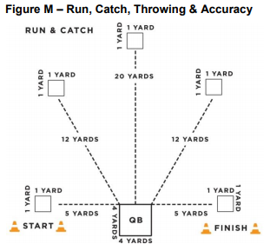

**Throwing for Accuracy**

1. Purpose: To measure the athlete’s ability to throw a football accurately.
2. Equipment: 5 footballs, measuring tape, field paint, cones, or numbered mats to mark catching spots and start/finish lines.
3. Description: A starting line, finish line, quarterback box, and 5 catching boxes should be marked/ placed on the field. The catching boxes should be marked 1-5 (left to right).
4. The quarterback box should be placed in between the starting and finish line.
5. The quarterback box should be placed in between the starting and finish line.
6. The quarterback box will be 4 yards X 4 yards.
7. Catching spots are 1 yard X 1 yard.
8. Catching Boxes 1 & 5 will be 5 yard from the quarterback box.
9. Catching Boxes 2 & 4 will be 12 yards from the quarterback box.
10. Catching Box 3 will be 20 yards from the quarterback box.
11. The starting line should be placed on the left side of the quarterback and the finish line should be placed on the right side of the quarterback.
12. The player being tested stands inside of the quarterback box. Five human targets/volunteers are placed in each catching spot. The athlete must throw to each target (in numerical order), gaining points for completed passes. The receiver must stay in the catching box. Scoring is based on accuracy of the throw not on the volunteer catching the pass.
13. Scoring: Athletes will receive points for completed passes.
    1. 2 pts: For an accurate & completed throw.
    2. 0 pts: Receiver is unable to catch or touch ball in targeted area. If the ball hits the ground prior to reaching the target, the throw will be recorded as a failed attempt.
    3. Athletes can gain a maximum of 10 points in this drill.

**Throwing for Distance**

1. Purpose: To measure the athlete’s ability to throw a football for distance.
2. Equipment: 3-5 footballs; measuring tape; field paint; cones
3. Description: Athlete gets two attempts to throw football as far as possible. The goal line of a Special Olympics flag football field can be used as the starting line. (See Figure M-1)
4. Scoring: Athletes will receive a maximum of 5 points per throw.
   1. 1 pt: 0-10 yards
   2. 2 pt: 10-20 yards
   3. 3 pt: 20-30 yards
   4. 4 pts: 30-40 yards
   5. 5 pts: 40+ yards
   6. Athletes can gain a maximum of 10 points in this drill.

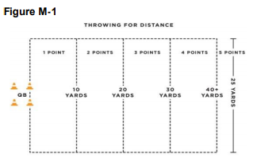

**Agility & Speed: Hand-Off**

1. Purpose: To measure the athlete’s speed, agility and ability to receive a hand-off.
2. Equipment: 3 footballs, eight cones, field paint, measuring tape, and stop watch
3. Description: The ball is marked at the 20 yard line or 20 yards from the goal line. The quarterback will be position 20 yards from the goal line. Athlete begins 5 yards behind the quarterback and between the cones. (See Figure M-2)
   1. The quarterback will give the signal and hand the ball off to the athlete.
   2. The clock will start on the quarterbacks signal.
   3. The athlete must maneuver around the four cones and sprints to the finish line/end zone between the cones and must maintain possession of the football.
   4. Each cone will be 1.25 yards apart
   5. A fumble at the exchange between the QB and the athlete would be a redo.
   6. If an athlete losses control of the ball, the clock continues to run. The athlete can recover the ball. However, if the ball goes outside the 3m lane, the athlete can either pick up the nearest back-up football or recover the errant football to continue the event.
4. Scoring: The athlete will receive two attempts. The athlete can receive a max of 5 points per attempt for a total of 10 points.
   1. The athlete will be timed from QB’s signal to when he/she crosses the finish line between the cones with possession of the football.
   2. One-second will be added for every missed cone.
   3. Conversion Chart will indicate score. Athlete can gain a maximum of 10 points.

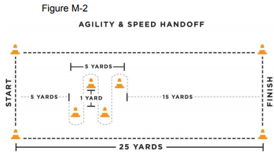

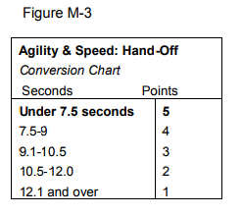

**Flag Pulling**

1. Purpose: To measure the athlete’s ability to pull an opponent’s flag.
2. Equipment: 5 footballs, four cones, 5 volunteers and measuring tape
3. Description: The athlete stands in the middle of a 5 X 5 yard grid.
   1. Volunteers will one at a time jog through the grid with a football and attached flags. The athlete attempts to pull the volunteers flag before the volunteer leaves the grid. Volunteers will move straight through the box without attempting to elude athlete. Speed of volunteers will increase incrementally until the last volunteer is sprinting through.
   2. This is not a timed event. Each additional attempt will not start until the athlete has repositioned themselves at the center of the grid.
4. Scoring: The athlete will receive 5 attempts. The athlete will receive two points for successful flag pull. The athlete will receive one point for any unsuccessful flag pull in which either the flag or ball carrier was touched, but the flag did not come off. The athlete will receive zero points for any unsuccessful flag pull in which the flags or ball carrier are not touched at all. Once the jogging volunteer leaves the grids, he/she must reposition themselves in the center of the grid. Athletes can gain a maximum of 10 points in the drill.

