Cycling

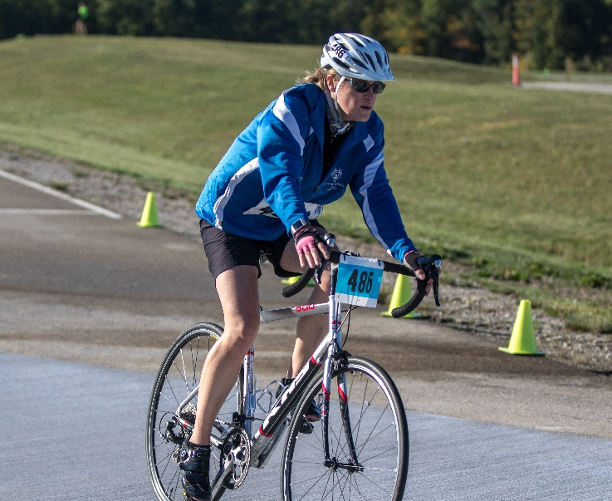

SOMI-Specific Information

Sport season:
June – September

Culminating State Events:
State Fall Games

Events Offered:
Three (3) Wheel Bike
250M Time Trial
500M Time Trial
1K Time Trial
3 K Time Trial

Individual:
500 M Time Trial
1K Time Trial
3K Time Trial
5K Time Trial
5K Road Race
10K Road Race

Unified:
3K Unified Time Trial
5K Unified Time Trial
3K Unified Tandem Time Trial
5K Unified Tandem Time Trial
5K Unified Team Road Race
10K Unified Team Road Race

National Governing Body:
United States Cycling Federation
One Olympic Plaza
Colorado Springs, CO 80909 (719) 866-4581

Uniform Guidelines & Equipment
- The recommended cycling uniforms consist of a jersey, cycling shorts, and cycling gloves although this uniform is not mandatory. Shorts should be mid-thigh in length.
- Any team entered in a unified event- Team Time Trial or Tandem events must all wear the same cycling uniform.
- If wearing long pants, only form fitting pants may be worn (for example spandex pants). Clothing should not be too big or too loose as to get caught in the bike while riding. The bike inspector will have the final say on what shorts and/or pants will not be allowed.
- The Special Olympics Michigan logo must be on the jersey. The area will be FINED the cost of putting the logos on the uniforms for each team sport without logoed uniforms. Area Directors will be notified.
- Cycling Helmets must meet the safety standard of the National Governing Body. Certification must be inside each helmet and should NOT be older than 3 years, all equipment must pass safety inspection. Large helmet sizes, if needed, can be found at West MI Cycling in Grandville and Holland.
- Hats, bandanas, du-rags, and denim may not be worn during competition or practice. Headwear for religious or medical reasons are acceptable but must be brought to the attention of the Games Director prior to competition.
- Jewelry is not allowed.
- Any standard bike that complies with the safety standards may be ridden.
- All bicycles and helmets must pass a safety inspection on race day prior to competition. The safety inspection ensures that the bicycle is road ready and the helmet fits properly. Inspections will be done in the morning by a certified bicycle mechanic or qualified mechanic onsite.
- It is the responsibility of the coach and athlete to bring equipment that is in working order. If a bicycle is deemed unsafe, the bicycle will not be allowed on the course. If adjustments need to be done, they must be done before the inspection period is over, prior to the start of competition. Any repairs needed are the responsibility of the coach.
- Adaptive bikes may be used in the time trial events if they do not impede other riders or cause an advantage. These bikes must also pass a safety inspection.
- Bicycles must have two working brakes.
- A bicycle with handlebars with forearm support or extend forward or upward may only be used in time trial events. The handlebars must be solidly plugged and attachments shall be attached securely so as to not impair steering. The bicycles may be inspected by the Chief Referee to be sure that the bicycle is safe and compliant. An inspection of every rider’s equipment is not required.

General rules
- Each athlete may enter two individual events plus a unified event. Thus, an athlete may compete in three events, if one event is a unified race.
- To qualify to register for the 5K events the athlete must be able to complete the race in 18 minutes or less. To qualify for the 10K events the athlete must be able to complete the events in 26 minutes or less. Athletes in the 10K will be heated by score.
- Entering Scores: To insure accurate information for heating please enter scores the proper way. Times should be recorded in the Qualifying Score box as follows: minutes, second, milliseconds. Example would be 12 minutes 29 seconds would look like this – 12:29.00
- All riders must be in the staging area near the start line at least fifteen (15) minutes prior to their event. Start time is forfeit time.
- The Starter shall countdown to the starting time using both an audible and visual countdown for each rider. Notification of time remaining to start will be given at various intervals in advance of the start. (i.e. 15 seconds, 10 seconds, 5,4,3,2,1, GO!).
- For hearing impaired riders a visual cue (flag or arm drop) shall be used to indicate the start of the clock/race.
- The rider shall start from a stationary position. The rider shall be held and then released, without being pushed, by a holder. The same holder shall perform the task for each rider in the division. The rider may opt to start with one or both feet on the ground at the start.
- At the discretion of the Chief Referee and organizing team, the time trial start order may be conducted fastest rider to slowest rider OR slowest rider to fastest rider depending on a number of factors including course layout, course condition, ability range of the field of riders and any other factors which may impact safety of the competition.
- Drafting and taking pace (side by side) is not allowed in time trials unless it is a team event. Partners can draft each other, but not other teams. Separation between two bikes should generally be at least three (3) bike lengths, unless passing.
- Cyclists who experience mechanical problems may change any part of the bicycle or the entire bicycle, if necessary, to finish the race. Assistance is allowed. A competitor remounting the bike after a crash or mechanical problem, and/or of a flat tire, may be pushed up to 10 meters. The athlete may make no progress unaccompanied by a bicycle (relegation or disqualification). In the case of a crash, flat tire and/or mechanical problem, the competitor may run with the bicycle to the finish line, staying on the course - in the case of Unified Sports tandem teams, BOTH riders must be touching the bicycle while crossing the finish line.
- Cyclists must keep at least one hand on the handle bars at all times – even at the finish of the race
- No cyclist may use or carry radios for communication with other riders or coaches during competition.
- Use of headphones of any style is prohibited while racing or training except on stationary equipment. Riders with certified hearing impairments may use hearing detection and amplifying devices
- A Time Trial consists of an individual racing against the clock. Competitors should depart at 20-second intervals for time trials.
- Use of modified bicycles will be permitted only in time trial events. The Chief Referee will decide if two-wheel and modified bicycles may compete together, based on the number of competitors, course conditions and ability level of the riders.
- A Road Race consists of a mass start. Competitors in road races will begin in mass starts according to division. For road races on multi-lap courses, everyone finishes on the same lap as the leader and will be given a prorated time unless the referee deems that there is too great a differential in speed among the competitors on the course. If this occurs, the referee will consult with the Event Director and Rules Committee on what action is to be taken. No times are recorded for Road Race Finals. The finish is determined by the placing/order of crossing the finish line. The race shall be declared finished when the front tire of the bike crosses the finish line. Awards will be handed based upon this finish. The Maximum Effort is not applicable in Road Race Finals.
- The start is by Starter’s pistol or whistle. For hearing impaired riders a visual cue (flag or arm drop) shall be used to indicate the start of the clock/race in addition to the use of a starter’s pistol or whistle.
- If the course is more than 2.5 kilometers in length, more than one division may ride on the course at once. The divisions may be started at one, two, or three-minute intervals
- The competitors shall wear their entry numbers according to instructions by chief officials
- Head coaches and other delegation members are not allowed on the track. Coaches may coach from the course sidelines.
- All finishes for multi-lap races shall have a bell rung to let athletes know that there is ONE lap to go; A colored flag shall be waived for any hearing impaired athletes indicating one lap to go.

Course Layouts
- Road Course - The course layout should be approximately 2-5 kilometers in length, with 2.5 kilometers optimal for shorter distance events and 5 kilometers or more for races over 15 kilometers in length. The distance for events may be approximate. The course can be the same for all races. The course should always be a loop. The road width should be at least 7 meters wide.
- For events over 1 kilometer the course design must consider the skill-sets of both the fastest and slowest riders. Out and back courses and courses with 180 degree turns are very difficult to control for safety and should not be used. Road events over 15 kilometers should, if possible, be run on longer courses and with slightly more challenging terrain.
- The road should be in good condition, free of potholes and not made of gravel. Prior to a race, pebbles, gravel and earth should be swept off the road. Sewers should be covered by a rubber plate.
- The racing course should be, whenever possible, closed to public traffic. The traffic should be stopped when a race is in progress.
- A staging area shall be provided for athletes, allowing them to congregate, warm-up, stage, and cool down. To ensure the safety of the competitors, these staging areas shall not overlap with the race course.
- Repair areas shall be available on site.
- The finish line should always remain the same for all races. The finish area should be at least eight meters wide and be adequately protected with fencing or barriers so as to prevent spectators from running onto the course.
- A safe exit from the course should be planned to accommodate riders completing their race. The marking of finishing lines should cover the full width of the course. The last 200 meters should be free of turns and curves. There should be at least 75 meters of straight road after the finish line to allow cyclists to slow without difficulty.
- Time Trial - The course layout for a time trial can be as short as 500 meters only if the number of starters is limited and the starting riders cannot interfere with lapping riders. If the course is a loop, the first turn after the starting area should be at least 100 meters from the start. The ideal course length is two (kilometers). The road must be wide enough to allow riders to pass each other with at least 1 meter between them side to side at time of passing. (Recommend 4 meters or greater). Time trial courses can be out and back if the lanes are separated by a physical barrier (a fence, concrete divider, grass median or curb). Time trials may be point to point courses and have a separate start and finish line. The finish line should remain fixed for all distances with a variable start line location for different distances.
- The time trial course should be closed to public traffic.
- The road surface should be in good condition, free of potholes and not made of gravel. Prior to the time trial, pebbles, gravel and earth should be swept off the road. Sewers should be covered by a rubber plate.

Unified Cycling Rules
- Unified Team events will include the 3K and the 5K Time Trials and the 5K and 10K Road Race. This will include a two person Unified Sports® Team; 1 Athlete and 1 Unified Partner. When two bikes are used, they must be 2-wheel bikes. The road race events will be a mass start event and the time trial events will start at 20-second intervals with the two person Unified Sports® Team starting side by side. The teams place will be determined when the last competitor’s front wheel (partner or athlete) crosses the finish line. The finish times for the members of the team shall not exceed a 3 (three) second difference from the fastest to the slowest rider.
- Unified tandem events will include the 3K and 5K Time Trial. The athlete or partner may assume the driver (front) or stoker (rear) position on the tandem. In accordance with UCI Para-cycling rules blind and visually impaired cyclists compete on the rear of tandem bicycles, with a sighted pilot.
- The unified partner must complete the Application for Participation for unified partners.

