Bocce

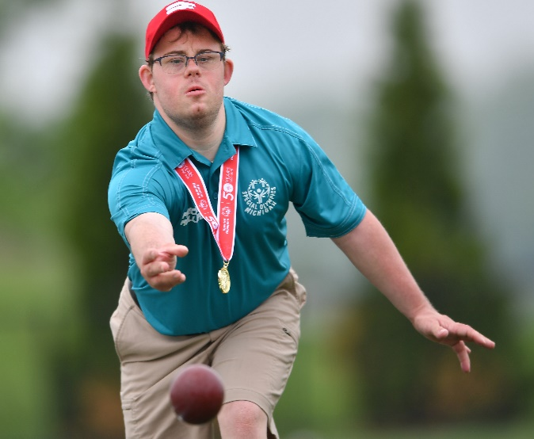

SOMI-Specific Information
Sport season:
April-June

Culminating State Event
State Summer Games

Events Offered
Singles
Doubles
Modified Singles
Modified Doubles
Unified Sports® Bocce Doubles (two players per team)
Unified Sports Bocce Team (four players per team)

National Governing Body
International Bocce Association, Inc.
187 Proctor Blvd.
Utica, NY 13501 (315) 773-9611

Uniform Guidelines
- Preferred Uniform: White collared shirt or T-shirt and dress shorts/pants.
- All members of bocce team must wear shirts and shorts/pants that are identical in color and style. Although not required, white is the traditional color of shirts in the sport of bocce.
- Shoes: Closed toe shoes or smooth soled athletic shoes are recommended. Shoes with any type of spikes are prohibited. Shoe should not damage or disrupt the court surface.
- Jewelry and denim may not be worn during competition or practice. Headwear for religious or medical reasons are acceptable but must be brought to the attention of the Games Director prior to competition.

Court Layout
- Court surface may be composed of stone-dust, dirt, clay, grass or artificial surface provided that there are no permanent or temporary obstructions in the court that would interfere with the straight line delivery of a ball from any direction. These obstructions do not include variations in grade or consistency or terrain.
- Court walls are the side and end walls of the court and may be composed of any rigid material. The walls must be at least as high as the bocce balls at all points. The side or end walls may be utilized during play for bank shots or rebound shots.
- The court size will be 60 feet in length and 12 feet in width. All courts should be clearly marked for the following:
  - Half Court Marker is the minimum distance the pallina may be played on first toss of pallina. The position of the pallina may change as a result of normal play; however, the pallina may never come to rest closer than the half point marker or the frame is dead.
  - Ten Foot Line (from backboard) = Foul line for shooting (hitting, spooking).
  - Thirty foot Line (from backboard) = Center court line. Pallina ball must pass this point at start of frame.
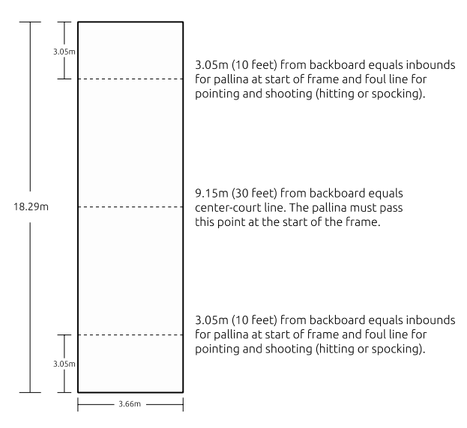

(60 ft.)

Equipment
- The game bocce is played with eight large balls and one smaller target or object ball called the pallina. There are four balls to a side or team, and they are generally made in two colors to distinguish the balls of one team from the opposing team. The large balls are also inscribed with distinctive lines to identify the balls of the players on the same team.
- Bocce balls may be composed of wood or composition materials and should be of equal size. Official league and tournament ball sizes may be from 107 mm (4.20") to 110 mm (4.33") and 2.0 to 2.25 lbs. weight.
- The color of the balls is immaterial provided that the four balls of one team are clearly and visibly distinct from the four balls of the opposing team.
- Pallina must not be larger than 63 mm (2-1/2") or smaller than 48 mm (1.875") and should be of a color visibly distinct from both bocce ball colors.
- A measuring device may be any device that can accurately measure the distance between two objects and is acceptable to the tournament officials.
- If an athlete is visually impaired a volunteer may hold a beeper near the pallina to identify its position during delivery.
- Ramps may be used when an athlete does not have the physical ability to roll with their hand or hands. Ramps and other assistance devices may be used with the approval of the Competition Committee. No mechanical aids shall be used to propel the bocce ball or pallina. Athletes using ramps must be placed in separate divisions from other players only for singles competition. All other tournament rules shall apply to athletes in the ramp divisions.

General Rules
- Each area may enter no more than 25% of their delegation in Bocce events. Athletes can register for 1 or 2 events.
- Three and four person single elimination, with consolation game, brackets will be created based on gender and score.
- The number of points needed to win a game is 12.
- At the State Summer Games all games will be played to whichever of the following circumstances occur first: 12 points or 10 frames or 25 minutes. If tied at the end of the game one sudden death frame will be played.
- Areas may have a pool (group) of alternates that may be interchangeable in their own area for more than one team. Enter bocce alternates in the singles and doubles events. Set up a team for alternates in the doubles called: your area number alternates (ex: A01 Alternates) and put all of your alternates in this team. Only Bocce alternates may replace Bocce drops. Teams may not be combined.
- Teams may not be combined between areas due to no shows or drops.
- There will be no coaching from sidelines or the courts; this includes spectators. Coaches will not be allowed on the courts. In doubles, discussion with any athlete is prohibited.
- A coin toss by the referee will determine which team has the pallina and choice of ball color. In the absence of a referee, the two team captains will execute the coin toss. The coin toss should take place on the court.
- Sequence of Play
  - The pallina is rolled by a member of the team which won the coin toss.
  - The player tossing the pallina must deliver the first ball.
  - The opposing team will then deliver their bocce balls until the point is taken or they have exhausted their four balls. This "nearest ball" rule governs the sequence of played balls.
  - The side whose ball is the closest to the pallina is called the "in" ball and the opposing side the "out" ball. Whenever a team gets “in,” it steps aside and allows the "out" team to deliver.
- Three Attempt Rule
  - The team possessing the pallina will have 3 attempts at placing the pallina within the 30’ mark and before the 10’ mark on the opposite end. If these 3 attempts are unsuccessful, the opposing team will have one opportunity to place the pallina. If this attempt is unsuccessful, the referee will place the pallina in the center of the court width at the 15.24 m (50') mark (opposite end foul line).
  - At no time does a team lose its earned pallina advantage of being able to deliver the first ball. After the above succession, the pallina shall not be touched.
- Initial Point
  - It is always incumbent upon the team with the pallina advantage to establish the initial point.
  - Example: Team A rolls the pallina and delivers the first ball. Team B elects to hit Team A's ball out of position. In doing so, both balls, Team A and Team B fly out of court, leaving only the pallina in the court. It is incumbent upon Team A to re-establish the initial point.
- Ball Delivery
  - A team has the option of rolling its ball down the court provided it does not go out-of-bounds or the player does not violate the foul markers.
  - A player also has the option of "spocking" or hitting out any ball in play in trying to obtain a point, or decreasing the opposing team's points.
  - All ball delivery attempts must be of an underhand style.
  - Hitting is sometimes known as shooting. Hitting is the action of rolling a ball which is thrown with sufficient velocity that it would hit the backboard if it missed the target.
  - Bank or rebound shot refers to playing a ball off either the sideboards or backboard.
- Modifications/Interpretations
  - The Event Manager/Tournament Director shall have the discretion to allow for certain modifications/interpretations of the current technical rules based upon a physical disability characteristic. Such interpretation shall be requested and ruled on prior to the athlete’s participation in a competition and shall not give advantage over another athlete. Delivery action interpretations will be concerned with the action a limb(s) is performing while delivering a pointing or hitting shot.
- Number of Balls Played -
  - Singles: the player is allowed 4 balls.
  - Doubles: the player is allowed to play two balls.
- Coaching
  - Discussion with any athlete and/or partner by a coach or spectator is prohibited once the athlete and or partner steps onto the field of play area as designated by the Tournament Director/Event Manager.
  - This applies to coaches on the court and in the stands.
  - If an official determines that a coach/partner/spectator is violating this rule, the official may sanction the offending individual. Sanctions may include: verbal warning, citing the coach/partner with unsportsmanlike conduct or expulsion from the game.
- Scoring
  - At the end of each frame (when both teams have exhausted all balls), scoring will be determined as follows: points are awarded to the team whose balls are closer to the pallina than the closest ball of the opposing team, which can be determined by viewing or by mechanical measurements.
  - A player may request a mechanical measurement (Measurements will be taken from the center side of the bocce ball to the center side of the pallina).
  - At the end of a frame, the referee announces the winning points and color to the players outside the court. Before the balls are removed, the referee should look to the players for agreement.
  - The players have a right to request a measurement if the players disagree with the referee.
  - When the player or team agrees with the number of points awarded, the court official then proceeds to remove the balls to start the next frame.
  - The scoring team for each frame will also win the pallina advantage for the subsequent frame.
  - The referee will be responsible for validity of the scoreboard and scorecard, so it is incumbent upon the team captain to verify the accuracy of the posted score at all times.
- Ties During a Frame
  - In the event that two opposing balls are equidistant from the pallina (tied), the team that rolled last will continue to roll until the tie is broken. Example: Team A rolls a ball for the pallina, and Team B rolls its ball for the pallina. The referee determines that they are both exactly 33 cm away from the pallina. Team B must roll until it has a point closer than 33 cm from the pallina. If Team B does roll up to the point and Team A hits that ball out re-establishing a tie, Team A must continue to roll until the tie is broken.
- Ties at the End of a Frame
  - In the event that the two balls closest to the pallina belong to opposing teams and are tied, no points will be awarded and the entire frame will be replayed.
  - The pallina returns to the team, which delivered it. Play resumes from the end of the court from which frame was last played.
- Rotation of Players
  - The players of any given team may elect to play their ball in any rotation provided that the player who tosses the pallina delivers the first bocce ball.
  - The rotation may vary from frame to frame; however, no player may deliver more than his/her allotted number of balls per frame.
- Checking Position of Points
  - Players may only proceed to the half court mark before delivering their ball(s).
  - Exceptions: For one player teams, player may proceed down the outside of court at any time to observe conditions. For two-player teams, one player may proceed down court to observe conditions before delivery. When only one team has exhausted all of its balls, the referee shall not be permitted to declare, by measurement or viewing, which team is "in."
- Timeouts
  - The official may grant a timeout whenever the circumstances appear to be valid. The timeout will be limited to ten minutes or less as predetermined by the Tournament Director.
- Delays of Games
  - Intentional delay of game: If, in the opinion of the official, the game is intentionally delayed without sufficient or valid reason, the official must give a warning. If play is not resumed immediately, the delaying team will forfeit the match.
  - Delays caused by weather, acts of God, civil disorder or other unforeseen reasons: In such delays, the ruling of the Tournament Director will be decisive and final.
- Forfeiture
  - Teams with less than the prescribed number of players will forfeit the match.
- Protests
  - Any protest to an official's or venue director's decision must be made by a certified Bocce coach before that team plays its next ball, or the decision will be considered as accepted.
  - Protest to forfeiture: If a team must forfeit a match as a result of not being present for a scheduled match, or as a result of violations here prescribed, no official protest will be acknowledged.
  - Protests will be acknowledged and judged on the basis of merit in circumstances not specifically discussed here.
- If during the course of a frame a ball or pallina should break, the frame will be considered dead. Replacement of a ball or pallina will be the responsibility of the Tournament Director.
- All courts must be groomed to the satisfaction of the Tournament Director before the start of each game. During Play: Courts may not be reconditioned during the course of the game. Obstacles or objects such as stones, cups, etc., may be removed during the course of a game.
- No player may play his or her ball until a pallina or another ball has come to a complete rest.
- During Play: Whenever possible, a player should move off the court when an opponent is playing.
- Players shall act in a sportsmanlike manner at all times. Any act which is deemed as poor sportsmanship, such as insulting language, gestures, actions or words which engender ill will, if flagrant, may result in disqualification.
- Immediately upon determination by the official that a foul has been committed, the official will notify the captains of both teams and inform them of the penalty imposed. The team fouled against has the option to decline any penalty imposed by the official and accept the lie of the ball(s) and continues playing. The ruling of the official is final, except as otherwise provided for hereafter.

Fouls
- Foul Line Fouls
  - In both pointing and hitting, the foremost part of the specific foul-line will not be surpassed by any part of the foot before the ball leaves the player's hand.
  - All fouls must be called by a referee as a result of witnessing the foul. One official warning may be granted for each team after which penalties will be prescribed.
  - The penalty for a team committing a second foul-line infraction will consist of one of two options:
    - The team fouled against will be awarded points as they were immediately preceding the foul, and the frame will end. The referee will make the final judgment as to how many points were actually "in" at the time. The team committing the foul will be awarded no points for the frame; or
    - The fouled against team may have the option of declining the penalty and completing the frame.
- Moving Ball or Pallina
  - The head official will not call for the next roll of a ball until the pallina or the currently played ball has come to a complete stop.
  - If a player, in any format of the game, delivers his or her ball before the pallina or a currently delivered ball has come to a complete stop, the ball just delivered should if possible and with safety be stopped by the referee before it reaches the balls “in contention,” be declared a dead ball and removed from the court.
  - If the referee cannot stop the ball before it reaches the “balls in contention”, the referee should replace the pallina and the nearest balls to where they were before the improper ball delivery took place, and remove the just delivered ball from the court.
- Playing Extra Balls
  - When a player rolls an extra ball during a frame, the ball in question is declared dead.
  - If possible and safe, the referee will seek to stop the ball just delivered before it reaches the pallina and the other balls "in contention", remove the just released ball from the court and declare the just released ball to be a dead ball.
  - If the just released ball does come in contact with the pallina and/or other balls "in contention" and these balls are moved from their original position, then the referee will place the balls back as close to their original position as possible and play will continue.
  - This condition will exist when a player on a two-player team plays three balls instead of two or a player on a four-player team plays two balls instead of one.
  - Two-Player Team: the remaining player on a two-player team will only have one ball to play.
- Illegal Movement of Your Ball - If a player moves one or more of his or her team’s balls, the ball(s) are removed from the court and considered dead and play continues.
- Illegal Movement of Opponents Ball - If, after all eight balls have been thrown, a player moves one or more of his/her opponent’s balls, the opponent’s balls that were moved will be awarded one point each. If a player moves one or more of his/her opponent’s balls, and there are remaining un-played balls, the referee will place the balls as close to their original position as possible and play will continue.
- Illegal Movement of Pallina - If the pallina is moved by a player, the opposite team will be awarded as many points as the number of live balls that were "in contention" plus the number of balls yet un-played. If the team fouled against has no balls "in contention" and no balls remaining, then the frame will be declared dead by the referee and started over at the same end.
- Accidental Movement of Balls/Pallina by Referee
  - During Play: If a referee, either in the course of measuring or otherwise, moves a ball "in contention" or the pallina, the frame is considered dead and started over at the same end.
  - After Play: If the point or points were obvious to the referee, the points will be awarded. All uncertain points will not be awarded and the frame is considered dead and started over at the same end.
- Interference with a Ball in Motion
  - By Own Team: When a player interferes with his/her team’s ball in motion, the referee, as a result of witnessing the foul, must declare the ball being thrown dead. If possible and safe, the referee, will seek to stop the ball just delivered before it reaches the pallina and the other balls "in contention", remove the just released ball from the court and declare the just released ball to be a dead ball. If the just released ball does come in contact with the pallina and/or other balls "in contention" and these balls are moved from their original position, then the referee will place the balls back as close to their original position as possible and play will continue.
  - By Opponent’s Team: If a player interferes with an opponent’s ball in motion, the team fouled against has one of the following options: 1) Play the ball over. 2) Declare the frame dead. 3) Decline the penalty, accept the lie of the touched ball(s) and continues playing.
- Wrong Color Ball Delivery
  - If the ball is replaceable: If a player delivers a wrong color ball, the ball may not be stopped by another player or the referee. The ball must be allowed to come to rest and replaced with the proper colored ball by the referee.
  - If the ball is not replaceable: If a player delivers a wrong color ball which cannot be replaced without disturbing another ball already in play the frame is declared dead and replayed from the same end.
- Wrong Rotation of Play
  - Initial Point: If a team wrongly delivers the pallina and its first ball, the referee will return the pallina and the first ball which was played out of rotation. The referee will then ask the other color player or team to deliver the pallina when restarting the frame from the same end of the court.
  - Subsequent Rolls: If a player delivers his or her ball when his or her team is "in" and the other team has balls left, the ball in question should if possible and safe be stopped by the referee before it reaches the "balls in contention", be declared a dead ball and removed from the court. If the referee cannot stop the ball before it reaches the "balls in contention", the referee should replace the pallina and nearest balls to where they were before the out of rotation delivery took place.

Modified Bocce Rules
- Modified bocce is designed for the athlete who does not have the ability to consistently throw a 4-1/2" ball sixty feet for 10 frames.
- Modified bocce singles and doubles will be played under the same rules as listed previously with the following changes:
  - Play will only be in one direction. Volunteers will bring the balls back to the athletes. Volunteers may place the balls in the lap of the athlete (in the case of an athlete being in a wheelchair), but they may not, nor may a coach, assist in the throwing of any ball.
  - The court size will be 30 feet in length and 12 feet in width. The court will be open (shaped like the letter "U") on one end. This opening will allow for the easy movement of wheelchair and severely physically-disabled athletes.
  - The bocce balls may be 4" in diameter and are approximately 1 pound.
  - Three Attempt Rule - The team possessing the pallina will have 3 attempts at placing the pallina within the 10’ mark and before the 5’ mark on the opposite end. If these 3 attempts are unsuccessful, the opposing team will have one opportunity to place the pallina. If this attempt is unsuccessful, the referee will place the pallina in the center of the court width at the 15.24 m (5') mark (from the closed end). However, at no time does a team lose its earned pallina advantage of being able to deliver the first ball. After the above succession, the pallina shall not be touched.

Unified Bocce Rules
- Unified Bocce is played as a doubles competition. Each Unified Sports doubles team shall consist of one athlete and one partner.
- There is no requirement within these rules as to who (Athlete or Partner) plays the pallina and first bocce ball. The order can change from game to game or frame to frame.
- Unified Bocce will follow the same rules as outlined previously with no changes to a typical doubles match.

How to get Qualifying Scores
- Play 3 modified games to assess the athlete’s ability…and to determine which Division they should play in. This score will be utilized to set divisions.
- Place the pallina on the center of the 30ft line & the player rolls all 8 balls towards it. Measure the closest 3 throws. Record the 3 distances on the Skills Assessment scoresheet in centimeters
- Change end… The pallina is placed on the center of the 40ft mark & repeat same process as for the 30 foot.
- Change end… The pallina is placed on the center of the 50ft line & repeat same process as for the 30 foot & 40 foot.
  - For modified, the pallina should be placed at the 15, 10, & 25 ft. lines
- Should the pallina be moved from its spot… it is replaced back before the next ball is thrown or any measurements are taken
- Total all 9 scores in centimeters, this is their qualifying score!
- Input the total score in centimeters into GMS.

Example at 30 Foot- Measure & record nearest 3 balls (cms)
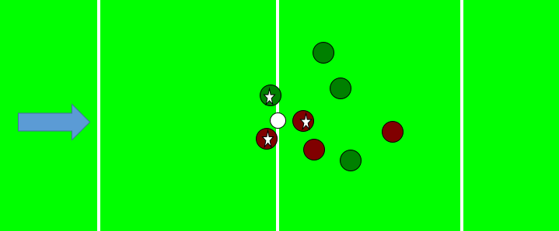

Example at 40 ft. – Measure & record nearest 3 balls (cms)
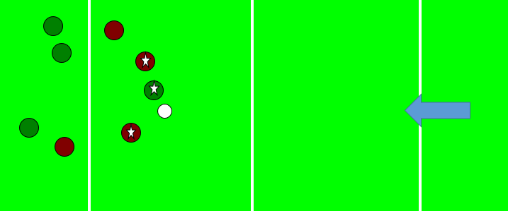

Sample Assessment Form
Name | 30 Feet |  |  | 40 Feet |  |  | 50 Feet |  |  | * Total  (Centimeters)
 | 1st Ball | 2nd Ball | 3rd Ball | 1st Ball | 2nd Ball | 3rd Ball | 1st Ball | 2nd Ball | 3rd Ball
Sample | 120 | 124 | 135 | 100 | 115 | 127 | 50 | 75 | 100 | 946 cm

How to measure
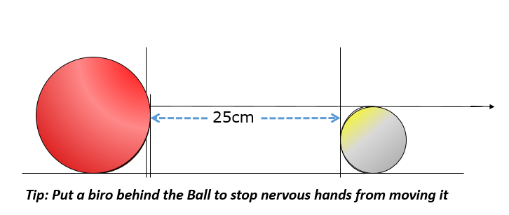
Measure from the center side of the bocce ball to the center side of the palli

