Beach Volleyball Skills Assessment
Follow the instructions below to complete a skills assessment for your athletes. The total scores will need to be entered when you complete your TEQ online at https://forms.gle/mA6TLNb6z3j9sPuf9

Event #1: Serving
Set-up
- Use a regulation-size court that is 16 meters long and 8 meters wide, 10 volleyballs, net height of 2.24 meters (7 ft, 4 1/8 in) for women and 2.43 meters (7 ft, 11 5/8 in) for men, measuring tape, and tape.
- Tape or chalk lines to mark the court outlining the target areas which value from two to four points
Test
- Athlete is given 10 serve attempts from the service area.
- Athlete may serve overhead or underhand.
Scoring
- Balls hitting on a line score the higher point value.
- Balls contacting the net, antennae, or landing out-of-bounds receive no points.
- The athlete’s final score is determined by adding together the points awarded for each of the 10 attempts.
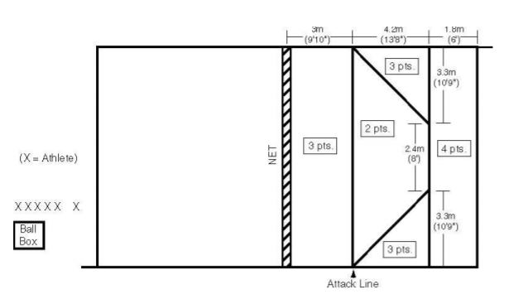

Event #2: Forearm Pass
Set-up
- You will need 10 volleyballs, a tosser, and a target. Mark a spot on the court that is three meters (9 ft, 10 in) from the right sideline and one meter (3 ft, 3 1/3 in) from the baseline and another spot three meters from the left sideline and one meter from the baseline. These will be the spots your athlete will pass from. Mark a spot for your target 2 meters away from the net and two meters from each sideline.
Test
- Athlete receives 10, two-handed, overhead-tossed balls from the tosser who is positioned across the net at the middle of the court. Athlete is given five attempts from the right spot and five attempts from the left spot. Poor tosses are repeated. Athlete passes the tossed ball to the target. The peak of the arc of each passed ball must be above the height of the net
Scoring
- The athlete will receive 1 point for each successful pass to the target. If the peak of the arc of each passed ball is not above the height of the net no points should be given.

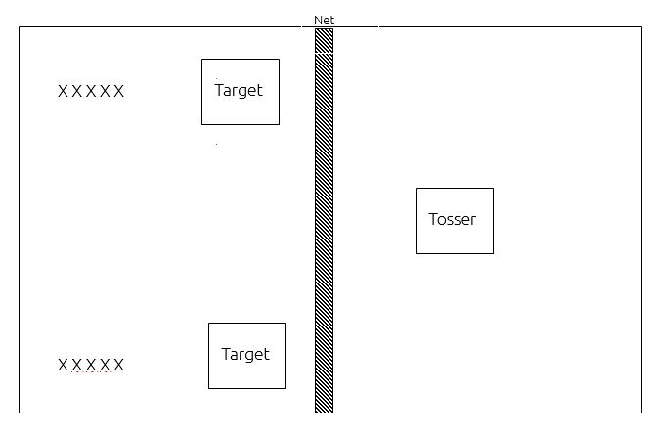

Event #3: Spike
Set-up
- You will need 10 volleyballs, a tosser, and chalk/floor tape. If your court does not have an attack line you will need to mark a line using your tape or chalk that is 3 meters from the net
Test
- A tosser will toss the ball in front of the athlete and 2 meters above the net. Tosses that are not at the proper height are repeated. The athlete stands in the court, three to four meters from the net, makes a spiking approach and spikes the ball over the net within the boundaries of the opponent’s front court. Each athlete receives 10 attempts.
Scoring
- The athlete receives two points for each spike that lands beyond the attack line in the backcourt and one point for each spike that lands between the net and the attack line within the opponent’s court. A tip (dink) or half-speed shot is not recorded as a spike. The athlete’s final score shall be the total of all 10 attempts.
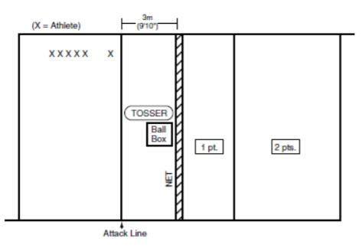

Event #4: Bump Set
Set-up
- Use half of a volleyball court and four volleyballs
Test
- Athlete alternately bumps (forearm passes) and sets the ball to himself/herself without stopping. Athlete first tosses the ball into the air and then bumps the volleyball. Athlete then must move under the ball to set-bump-set-bump-set, etc. Athlete must stay within the half-court lines.
Scoring
- Athlete is given four trials to gain his/her best score. The maximum score is 50 (25 bumps and 25 sets). Each legal hit is counted as one point, as long as the ball goes above the height of the net.
- A particular trial is finished when the athlete sets or bumps the ball twice in a row, illegally hits the ball, goes out of the court to play the ball or reaches a score of 50.

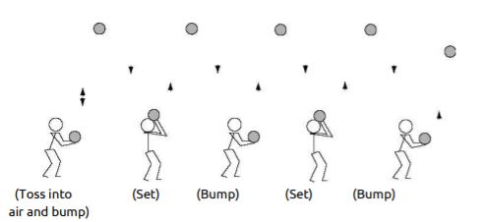

Scoresheet

Event #1: Serve: Athlete receives 0-5 points based on where the ball lands
Athlete Name | Serve 1 | Serve 2 | Serve 3 | Serve 4 | Serve 5 | Serve 6 | Serve 7 | Serve 8 | Serve 9 | Serve 10 | Total

Event #2: Forearm pass: 1 point for each successful pass
Athlete Name | Pass 1 | Pass 2 | Pass 3 | Pass 4 | Pass 5 | Pass 6 | Pass 7 | Pass 8 | Pass 9 | Pass 10 | Total
Event #3: Spike: Athlete receives 1 or 2 points based on where the ball lands. 0 points for tips or incomplete hits
Athlete Name | Spike 1 | Spike 2 | Spike 3 | Spike 4 | Spike 5 | Spike 6 | Spike 7 | Spike 8 | Spike 9 | Spike 10 | Total

Event #4: Forearm pass: 1 point for each successful pass. Max of 50 points
Athlete Name | Trial 1 | Trial 2 | Trial 3 | Trial 4

