Softball

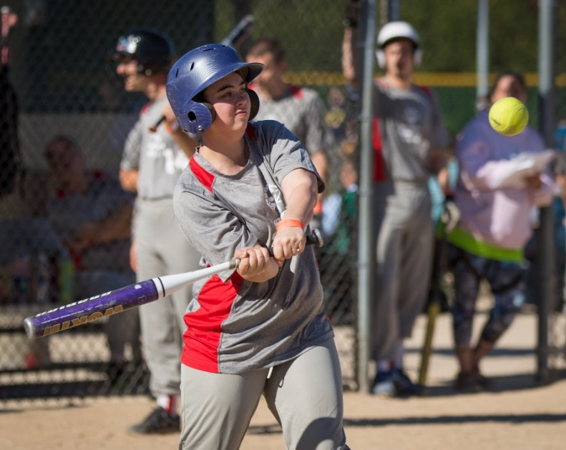

SOMI-Specific Information

Sport season:
June – September

Culminating State Events:
State Fall Games

Events Offered:
Team Competition Slow Pitch
Unified Team Competition Slow Pitch
Individual Skills Contest
T-ball
Coach Pitch (Regional/Area Only)

National Governing Body:
International Softball Federation
1900 S. Park Road
Plant City, FL 33563
(813) 864-0100

Uniform Guidelines
- Uniforms consist of a jersey, shorts or pants, stockings and sport shoes.
- All team members must have identical uniforms in color and design.
- The Special Olympics Michigan logo must be on the jersey. Penalty for each team sport without logoed uniforms the area will be FINED the cost of putting the logos on the uniforms. Area Directors will be notified.
- Undershirts must be similar in color to the jerseys or white and shall not have frayed or ragged edges.
- Caps, visors, sunglasses and headbands are optional for players but can be mixed. If more than one type is worn, they all must be of the same color and each of the same type must be of the same color and style. Plastic or hard visors are not allowed.
- All players must have the same color undershirt, shorts, or pants as their team members.
- All player pants shall be either all long or all short in style.
- Rubber soled athletic shoes or rubber cleats must be worn; metal spikes are not allowed
- Bandanas, du-rags, jewelry, and denim may not be worn during games or practice. Headbands, wristbands, and arm sleeves are acceptable. Headwear for religious or medical reasons are acceptable but must be brought to the attention of the Games Director prior to competition.

Equipment
- Ball Regulations: The completed 30.5cm (12 in) ball shall be between 30.2cm (11 7/8 in) and 30.8cm (12 1/8 in) in circumference, and shall weigh between 178.0g (6 ¼ ounces) and 198.4g (7 ounces). The flat seam style shall have not less than 88 stitches in each cover, sewn by the two-needle method. Either white with red stitching or yellow. Any ball modifications must have prior approval of the games director.
- Batting helmets are required for all batters and base runners.
- The catcher must wear a face mask and catcher’s type helmet. Chest protectors and throat guards are not required, but recommended.
- The official diamond shall have base lines as follows: 65’ and may be modified to either 60, 65 or 70 in accordance with NGB guidelines.
- The official diamond shall have pitching distance as follows: 40 – 50 ft. Typical is 46 ft. Pitching distance for Unified is 55ft.
- The double base is approved for use at first base. The following rules apply to the double base:
  - A batted ball hitting the fair portion is declared fair, and a batted ball hitting the foul portion only is declared foul.
  - If a play is made at first base on any batted ball, and the batter-runner touches only the fair portion, and if the defense appeals prior to the batter runner returning to first base, the batter runner is out. Note: This is treated the same as missing the base.
  - A defensive player must use only the fair portion of the base at all times.
    - Exception: On any live ball play made from first base foul territory, the batter-runner and the defensive player may use either base. When the defensive player uses the foul portion of the double base, the batter-runner can run in fair territory and if hit by a throw from the foul side of first base, it would not be interference. If intentional interference is ruled, the batter runner would be out. Note: The one meter line is doubled on throws from foul territory
  - After the batter-runner passes first base, they may return to either portion of the double base and may stand on either portion for the beginning of subsequent plays.
  - When tagging up on a fly ball, either portion of the base may be used.
  - *Note this is currently not at Fall Games.
- The Baserunner’s (second) home plate is approved for use. The dimensions for the second home plate are the same as the regulation home plate. The following rules apply to the baserunner’s home plate:
  - The second home plate should be located in foul territory 2.43m (8 ft.) from the back tip of the regulation home plate extended from the first base foul line.
  - The Commitment Line should begin 6.09m (20 ft.) up the third base line from the tip of home plate and marked through the baserunner’s line a minimum of .9m (3 ft.).
  - Once a baserunner passes the commitment line defensive players can touch only the regulation home plate and baserunners can only touch the second home plate. Runners must touch the second home plate to be declared safe at home and score a run. All plays at home plate are force outs.
  - Passing the commitment line is defined by one foot stepping entirely beyond the marked line or, if the line has been obscured, where that line was originally marked. Once the line has been crossed, the baserunner may no longer return to third base. Exception: when a live ball appeal for not tagging up on a fly ball or missing third base can be enforced, the baserunner may return to legally touch the base.
  - A baserunner may not be tagged out after crossing the commitment line. They may be tagged before crossing the line.
  - A baserunner who touches or crosses the regulation home plate shall be declared out (the ball remains live).
  - *Note this is currently not at Fall Games.
- The Official Bat
  - Shall be of one-piece construction, multi-piece permanently assembled or two piece interchangeable construction. If the bat is designed with interchangeable components it must meet the following criteria: Mating components must have a unique locking key to prevent uncertified equipment combinations in the field. All component combinations must meet the same standards as if it were a one piece bat when combined or a portion of a one-piece bat if separated.
  - Shall be made of one piece of hardwood, metal, bamboo, plastic, graphite, carbon, magnesium, fiberglass, ceramic, or any other composite material approved by the ISF Equipment Standards Commission or NGB Standards.
  - Can be laminated, but must contain only wood or adhesive and have a clear finish (if finished).
  - Shall be round and shall be smooth.
  - Shall not be more than 86.4cm (34 in) long, nor exceed 1077.0 g (38 ounces) in weight.
  - Shall not be more than 5.7cm (2 ¼ in) in diameter at its largest part. A tolerance of 0.80mm (1/32 in) is permitted to allow for expansion
  - Shall not have exposed rivets, pins, rough or sharp edges, or any form of exterior fastener that would present a hazard.
  - A metal bat shall be free of burrs and cracks. If metal, shall not have a wooden handle.
  - Shall have a safety grip of cork, tape (no smooth, plastic tape), or composition material. The safety grip shall not be less than 25.4cm (10 in) long and shall not extend more than 38.1cm (15 in) from the small end of the bat. Resin, pine tar, or spray substances placed on the safety grip to enhance the grip are permissible on the grip only. NOTE: Tape applied to any bat must be continuously spiral. It does not have to be a solid layer of tape. It shall not exceed two layers.
  - The official bat shall not be an ‘Altered Bat.’ The weight, distribution of weight, and length of the bat, as well as all other characteristics of the bat must be permanently fixed at the time of manufacture and may not be altered in any way thereafter, except as otherwise specifically provided, or a specification approved by the ISF Equipment Standards Commission or NGB Standards.
- Facemasks: Any defensive or offensive player can wear an ISF or NGB approved plastic face mask/guard. Face masks/guards that are cracked or deformed, or if padding has deteriorated or is missing, are prohibited from use and must be removed from the game. Catchers cannot wear the plastic face mask/guard in place of the regular mask with throat protector.

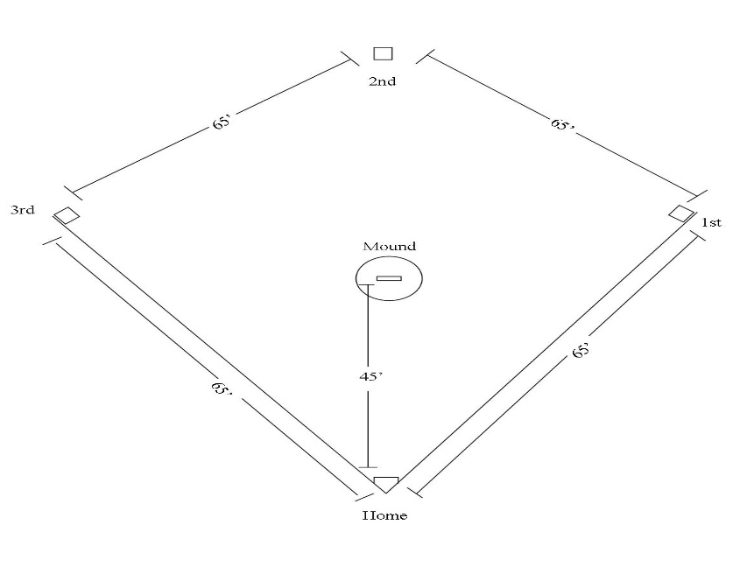

Team Size
- Team rosters shall contain a minimum of 11 players and a maximum of 15 players. You may register 3 athletes as alternates.
- A team may start a game with 10 players and if an injury or ejection occurs, may finish with 9 players. Games may not begin with 9 players, in this case a forfeit will be declared.
- Alternates attend the event only when replacing a registered athlete who does not attend. When dropping an athlete prior to a SOMI Culminating Event or at the event site, only registered alternate athletes can be added. Alternates do not attend state events unless activated in the sport. Awards are only given to team members listed on rosters and present the day of the event. (Ex. If you have 8 people listed on your original roster you can only bring 8 people to the event, if you drop one athlete they are replaced with one alternate.) It is strongly suggested to list alternate athletes. Unified Partner athletes will follow the same procedures as athlete alternates.
- Each coach must see to it that each athlete has frequent opportunities to participate.
- All coaches are required to turn in 3 scores prior to the state event, in which their roster must be the same for all 3 scores.

General Rules
- Length of play
  - A game will consist of 7 innings
  - A time limit of one hour and five minutes will be utilized for all games. No new inning can begin after this limit.
    - With 1:05 time limits, the umpires make an announcement at 50 minutes and finish the inning they're in, then at the start of the next inning, if time is still left, we start the all you can score rule for both teams and declare it to be the last inning. If the game reaches the seventh inning, it automatically is the last inning and all you can score.
  - A game will be deemed complete if a team has a 15 run lead after four innings or 12 runs after 5 innings. The leading team will be considered the winner. This is referred to as the "run ahead rule."
  - In the case of inclement weather, two complete innings shall be considered a complete game. The umpire is empowered to call a game at any time because of darkness, rain, fire, panic or other cause, which puts the patrons or players in peril.
- A 7-run or 3-out rule will be utilized for all innings, except the final inning. In the final inning, if one team is 12 runs ahead, that half of the inning shall be declared over and the other team will come to bat for their last time. If they score 12 runs to tie the score, the game will be declared over, and a tie will be recorded.
- A foul ball following 2 strikes is an out.
- In traditional play, coaches will be able to bat all eligible players listed on the roster. This batting order cannot change except for the following situations: 1. The Batter is Out When playing shorthanded and it is the dropped player’s position in the batting order. 2. If an athlete is ejected, it will be considered an out when his/her time to bat arrives. 3. A new athlete may be added to the bottom of the batting order at any time.
- An ejected minor or Special Olympics athlete that requires supervision may remain on the grounds. Further actions by the ejected player will result in that team forfeiting the game.
- Sliding is allowed, but not recommended.
- No assisted devise allowed during team play.
- Coaching
  - Each coach must see to it that each athlete has frequent opportunities to participate.
  - Coaches are not allowed to assist defensively. Coaches must remain in the dugout area while their team is playing defense.
  - A base coach is a member of the team at bat who resides within one of the coaching boxes on the field to direct players of the team in running the bases. Two coaches are allowed. One coach can have, in his possession in a coach’s box, a score book, pen or pencil, and an indicator, all of which shall be used for score keeping or recordkeeping purposes only. No communication equipment is allowed.
  - There will be no more than two coaches for each team to give words or signals of assistance and direction to the members of their team while at bat. One should be stationed near first base and the other near third base. Each coach must remain in his/her coaches’ box.
- Tie Breaker
  - Starting with the top of the 8th inning, or the first inning after the time limit, and each half inning thereafter, the offensive team shall begin its turn at the bat with the player who is scheduled to bat last in the respective half inning being placed on second base. The player who is running can be substituted in accordance with the substitution rules.
- Pitching Regulations
- The pitch starts when the pitcher makes any motion that is part of his/her windup after the required stop. Prior to the required stop, any motion may be used.
- Legal Delivery
    - The pitcher must not make any motion to pitch without immediately delivering the ball to the batter.
    - The windup must be a continuous motion. The pitcher must not use a windup in which there is a stop or reversal of the forward motion.
    - The pitcher must deliver the ball toward home plate on the first forward swing of the pitching arm past the hip with an underhanded motion.
    - The pivot foot must remain in contact with the pitcher's plate until the pitched ball leaves the hand.
  - The pitcher shall not pitch the ball behind his/her back, through his/her legs, or from the glove.
  - The pitch shall be released at a moderate speed. Note: The speed is left entirely up to the judgment of the umpire.
  - The ball must be delivered with a perceptible arc of at least 6 feet and not more than 10 feet from the ground.
  - The pitcher shall not deliver a pitch unless all defensive players, except the catcher who must be in the catcher's box, are positioned in fair territory.
- Batting
- The On-Deck Batter
    - Shall take a position within on-deck circle nearest his bench.
    - May not interfere with the defensive player's opportunity to make a play.
- Batting Order
    - The batting order must show the first and last name, uniform number and the position on the line-up card and must be delivered before the game by the manager or captain to the plate umpire. In Unified, the line-up card shall designate “A” for athlete and “P” for partner next to that players’ information.
    - The batting order must be followed throughout the game unless a player is replaced by a substitute. When this occurs, the substitute must take the place of the removed player in the batting order.

- Batting Position
    - The batter must have both feet completely within the batter's box prior to the start of the pitch. They may touch the lines, but no part of their foot may be outside the lines prior to the pitch.
- A Strike is Called by the Umpire
    - For each legally pitched ball entering the strike zone before touching the ground and at which the batter does not swing. Note: It is not a strike if the pitched ball touches home plate and is not swung at.
    - For each pitched ball including an illegal pitch, struck at and missed by the batter.
    - For each foul tip or ball, including the third strike.
- A Ball is Called by the Umpire for each legally pitched ball that:
    - Does not enter the strike zone.
    - Touches the ground before reaching home plate.
    - Touches home plate and at which the batter does not swing.
- Batters do not advance after getting hit by a pitch
- Fielding
  - When a ball is put in play by the batter and fielded by the defense, the Umpire will call time when the ball is held by the defense in the infield. Runners halfway to the next base will be allowed that base.
  - The Infield Fly Rule will be in effect when there are less than two outs and there are runners on first and second or the bases are loaded.
  - The umpire will announce, “Infield Fly” when one of the above conditions exists and a batter hits a pop-fly in the infield. Please note that an infield fly is a judgment call by the umpire and NOT subject for controversy. When the Infield Fly Rule is declared, the batter is automatically OUT. The ball is alive and runners may advance at the risk of the ball being caught. The runner may also tag-up and advance after a defensive player has touched the ball.
- Base Running
  - Players can only overrun first base without being in danger of being tagged out.
  - Sliding is allowed, but not recommended unless practiced.
- Courtesy Runner
- Any eligible player on the official line-up including available substitutes may be used as a courtesy runner. Only one courtesy runner may be used per inning. In Unified play, only an Athlete may courtesy run for an Athlete and only a Partner may courtesy run for a Partner.
- Courtesy Runners whose turn at bat comes while on base will be called out. A second courtesy runner cannot be substituted at this time.

- Players
  - A team shall consist of players in the following positions:
Ten players: pitcher (F1), catcher (F2), first baseman (F3), second baseman (F4), third baseman (F5), shortstop (F6), left fielder (F7), left center fielder (F8), right fielder (F9) and right center fielder (F10).
- Re-Entry
  - Any player may be substituted or replaced and re-entered once, provided such players occupy the same batting position whenever they are in the line-up.
  - If a manager/coach removes a substitute from the game and re-enters the same substitute later in the game, this is not considered an Illegal Re-Entry.

Unified Softball Competition
- The roster shall contain a proportionate number of athletes and partners. “Equal” means eight athletes and seven unified partners, seven athletes and eight unified partners, six athletes and nine unified partners or nine athletes and six unified partners.
- During competition, the line-up shall never exceed five traditional athletes and five partners at any time. Failure to adhere to the required ratio results in a forfeit.
- Each team shall have an adult non-playing head coach responsible for the line-up and competition. Unified partners should not be involved in coaching.
- The batting order shall alternate athletes and partners. If unable to follow that order an out must be taken when the missing athlete or partner’s place appears in the batting order.
- During competition the following position requirements are: two athletes and two partners in both the infield and the outfield, and one athlete and one partner as pitcher and catcher.
- Unified partners must fill out the Unified Sports® Partner Application for Participation form.
- Umpires shall warn any athlete whose play is deemed dangerous. A second infraction for dangerous play shall result in disqualification from the game. This rule is to ensure that a play does not create a health and safety risk for other players.
- A limit of over-the-fence home runs will be used in all Unified divisions. The following limitations are per team per game: Two (2). For any excess home runs, the ball is dead, the batter is out, and no runners can advance. Note: Both athlete and partner home runs count toward the Unified limit.

T-Ball Competition
  - Playing Area
  - a. Bases may be modified from a standard distance of 60 feet.
  - d. The distance from home plate to the pitcher’s rubber may be modified from a minimum distance 40ft.
  - A “neutral zone” will be marked in an arc of 45 feet, 11 1/4 inches from home plate. Any batted ball that does not cross this line will be designated a foul ball.
  - A coaches’ circle will be located 9 feet, 10 1/4 inches beyond second base and made with a 5 feet, 11 inch diameter. One coach from the defensive team may be allowed to stand in this circle while his/her team is on the field.
- Team and Players
  - Each team must have 10 players to start a game.
- General Rules and Modifications
  - A batting tee will be placed directly on home plate. A coach from the batting team will adjust the tee to fit the batter.
  - b. To start play, the catcher will place the ball on the tee and the umpire will say “play ball.”
  - c. If the batter completely misses the ball and the tee, the attempt shall be ruled a strike.
  - All defensive players must stand behind the neutral zone before the ball is hit. They may come into the neutral zone after the ball is hit to field it.
  - If a batted ball does not leave the neutral zone, and the defensive player does not touch it, the ball will be called a foul ball.
  - If the batter has two strikes and fouls off the third attempt, he or she shall be declared out.
  - The batting team’s half of the inning shall end when three outs have been made or the batting order is complete.
  - A regulation game consists of six innings. A time limit of one hour shall be in force for all games.
- Substitutions
  - Substitutions may be made whenever a “timeout” is called.
  - Any of the starting players may leave and re-enter the game.
- Coaches Privileges
  - Two base coaches are allowed for the offensive team, one in the first base coach’s box and one in the third base coach’s box. The coaches must remain in those boxes while their team is at bat.
  - One coach from the defensive team may be allowed on the field, and he/she must remain in the coach’s circle behind second base. Also, he/she must make a reasonable attempt to avoid any ball that is thrown in his/her direction

Individual Skills Contest
The Individual Skills Contest is designed for lower ability athletes who have not yet developed the skills necessary to participate meaningfully in team competition. Athletes may not be assisted. Modifications will be made for hearing or visually impaired athletes.
Four events comprise the Individual Skills Contest: base running, throwing, fielding, and hitting. The athlete's final score is determined by adding together the scores from these four events. Athletes will be pre-divisioned according to their total scores from these four events. Each event is diagrammed with the suggested number and placement of volunteers who will administer them. It is also suggested that the same volunteers remain at an event throughout the competition so that consistency is provided.

Event #1: Base Running
- Purpose: To measure the athlete's base running ability.
- Equipment: Three bases, home plate, and a stopwatch.
- Description: Bases are set up like a baseball diamond and positioned 19.81 meters (65') apart. The athlete is instructed to start on home plate and run around the bases as fast as possible, touching each base en route.
- Scoring: The time stops when the athlete touches home plate, after circling the bases. The time elapsed in seconds is subtracted from 300 to determine the points score. A penalty of five seconds for each base missed or touched in an improper order shall be assessed. The better of two trials is recorded.

Event #2: Throwing
- Purpose: To measure the athlete's ability in throwing for distance and accuracy.
- Equipment: Regulation field, two measuring tapes, softballs, and two small cones or marking stakes.
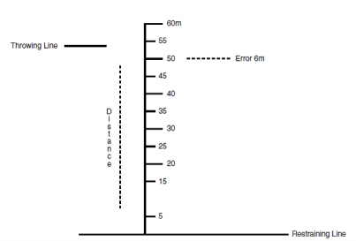
- Description: The player being tested stands behind the restraining line, back far enough to take one or more steps in preparation for throwing. The player has two trials to throw the softball as far and as straight as possible down the throwing line, without stepping over the restraining line. Coaches, assistants, or other waiting players should be positioned in the field to indicate, using a cone or marking stake, the spot where each ball first touches the ground. If a player steps on or over the line before releasing the ball, the trial must be repeated. There will be a maximum of two repeats. (See Figure W)
- Scoring: The net throwing score equals the throwing distance, measured at a point on the throwing line straight across from (perpendicular to) the spot where each ball first touches the ground. The better of the two throws is measured and recorded as the player's score. Subtract the error distance from the center li

Event #3: Fielding
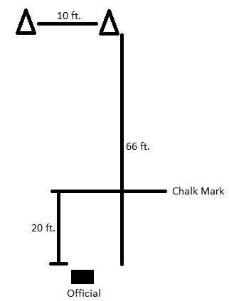
- Purpose: To measure the athlete's fielding ability.
- Equipment: 30 cm (12") softballs, measuring tape, chalk/line, cones.
- Description: The athlete will stand between and behind the two cones. The official must throw the ball on the ground to the athlete between the cones. The throw to the athlete must hit the ground before the 6.10 (20") chalk mark. The athlete may move aggressively toward the ball. If the thrown ball is outside of the cones, the throw must be repeated. Each athlete gets five fielding attempts per trial. Each athlete receives two trials. (See Figure X)
- Scoring: The athlete receives five points for a clearly fielded ball (either caught in glove or trapped against the body, but off the ground); two points for a ball that is blocked; and zero points for a missed attempt. The maximum score is fifty points.

Event #4: Hitting
      - Purpose: To measure the athlete's ability to hit for distance when hitting off a batting tee.
      - Equipment: Batting tee, 30 cm (11’ 3/4") red stitch restricted-flight softballs, bat, measuring tape, and chalk.
      - Description: Standing in a regulation size batter's box (i.e., 2.31 meters (77") by 99 cm (3' 3")), the athlete is instructed to hit the ball off the tee. The athlete receives three attempts.
      - Scoring: The distance of the longest hit shall determine the athlete's final score. The distance of a hit is measured from the batting tee to the point where the ball first touches the ground. The distance is measured to the nearest meter (i.e., 1 meter = 1 point, 45 meters = 45 points).

